Spring BOOT DEV TOOL

Problem

-When you running spring boot application if changes done in source code then mannuly need to restart the application

Solution

Spring Boot Dev Tools

-spring-boot-devtools to the rescue

-automatically restarts the application when code is updated

- add dependency in pom file no additional code required

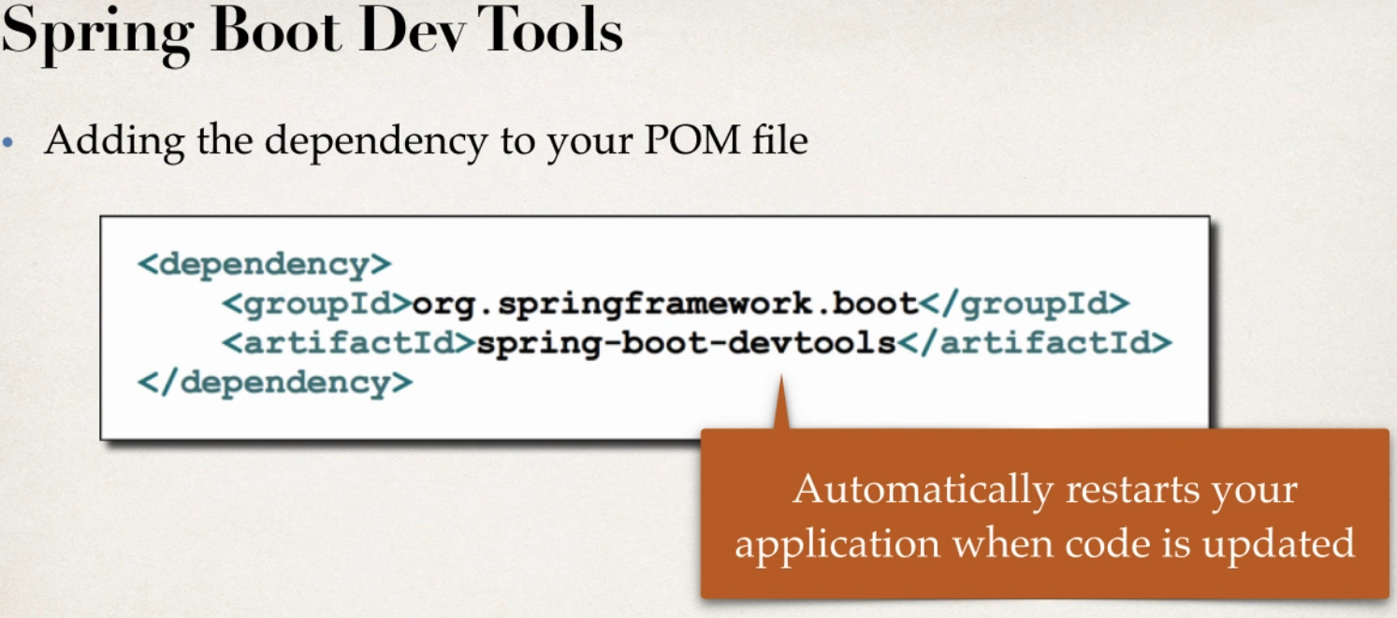

Development Process

1 edit pom.xml add spring-boot-devtools

2 add new REST end point to app

3 verfiy app is automatically lodaded

Spring Boot Actuator

Problem

Q1 how can I monitor and manage my application ?

Q2 How can I check application health?

Q3 How can I access application metrics?

Solution

Spring BOOT Actuator

-Exposes endpoints to monitor and manage your application

- you easily get the DevOps functionality out-of-box

-simply add dependency to pom file

-REST point are automatically added to your application

-no need write additional code you get New REST end points for free

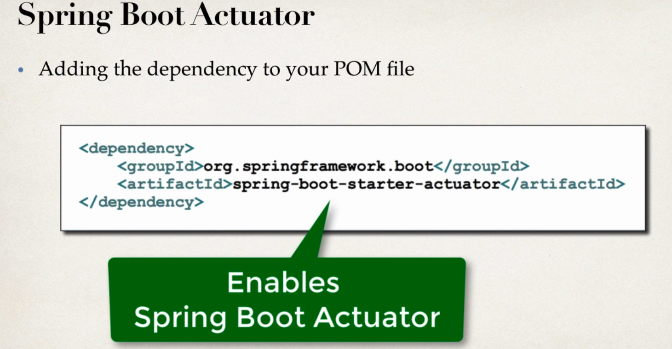

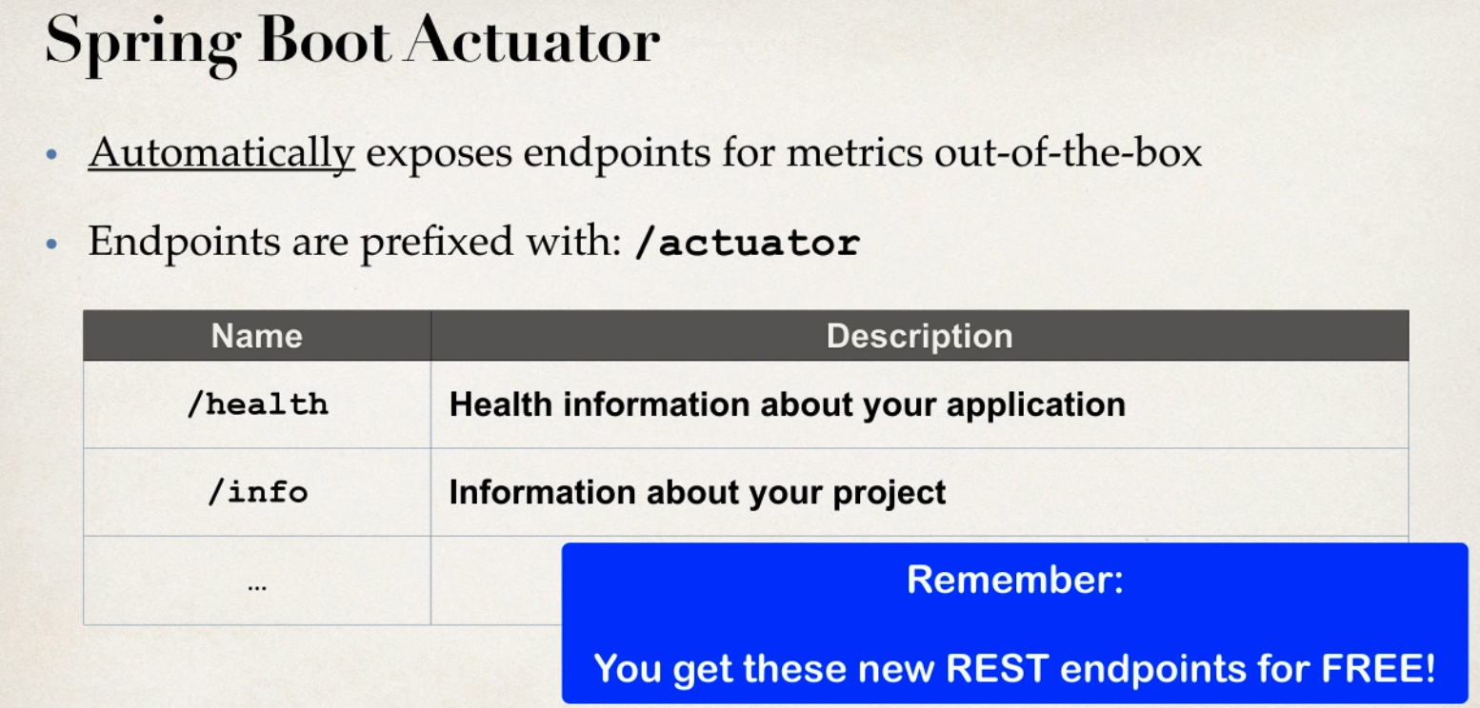

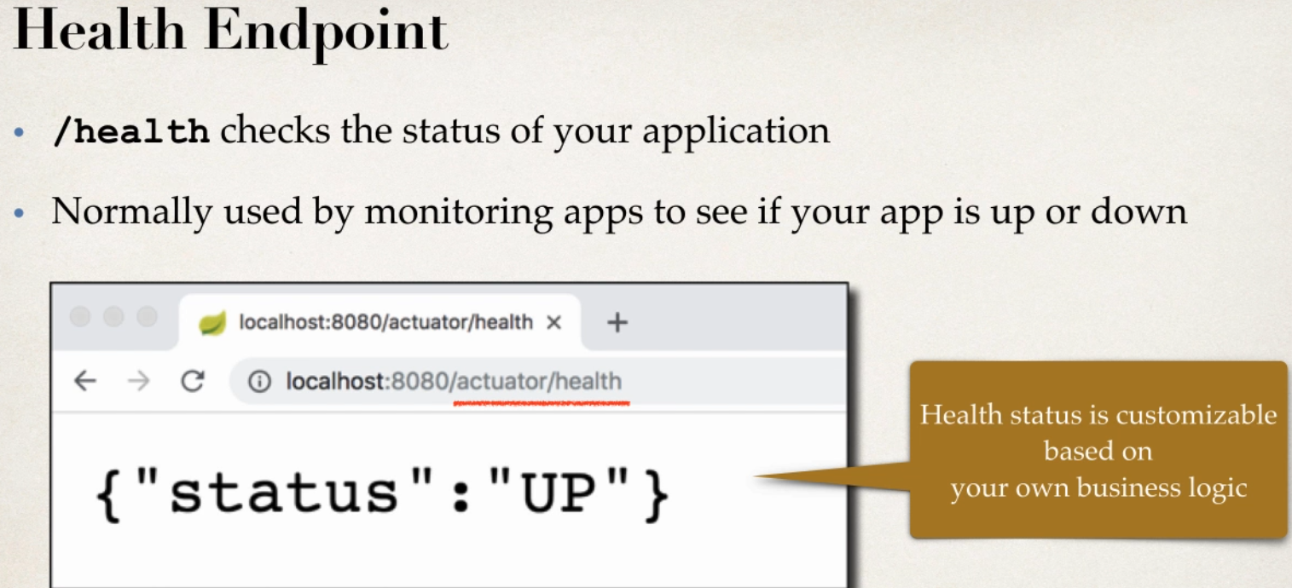

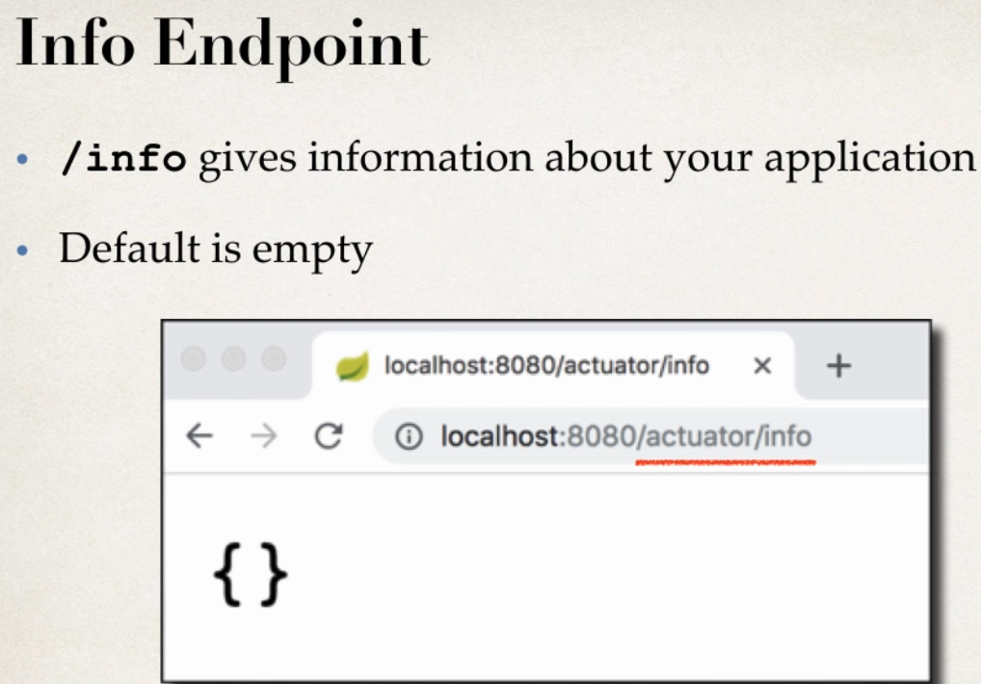

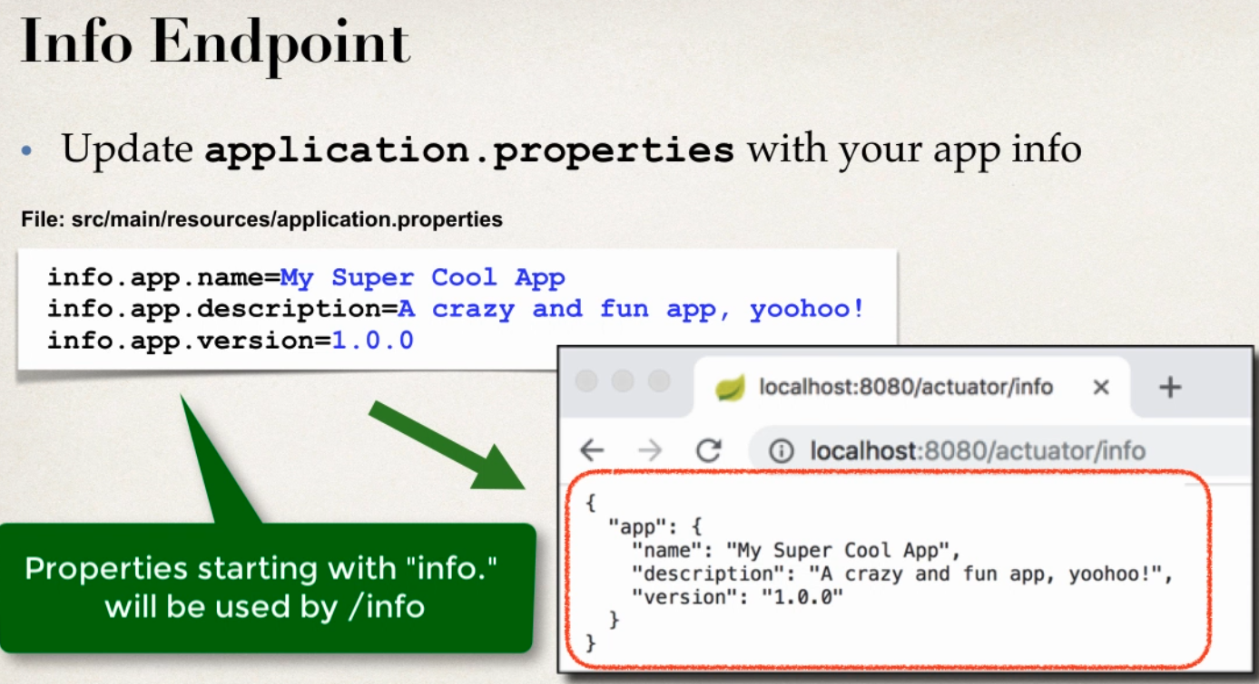

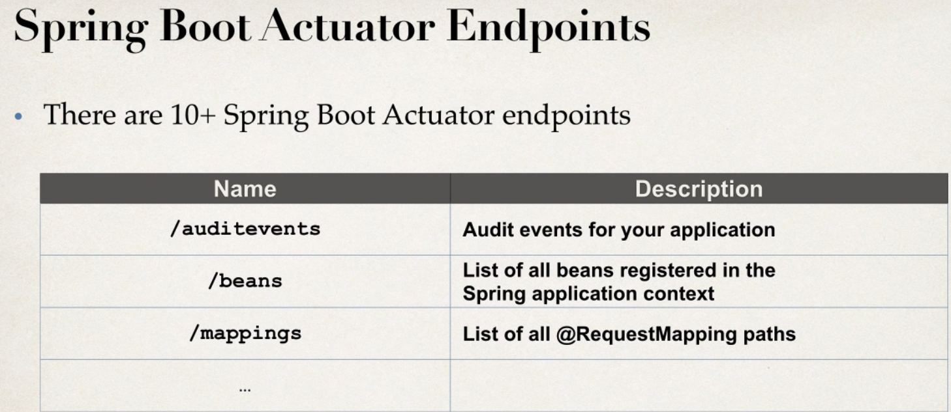

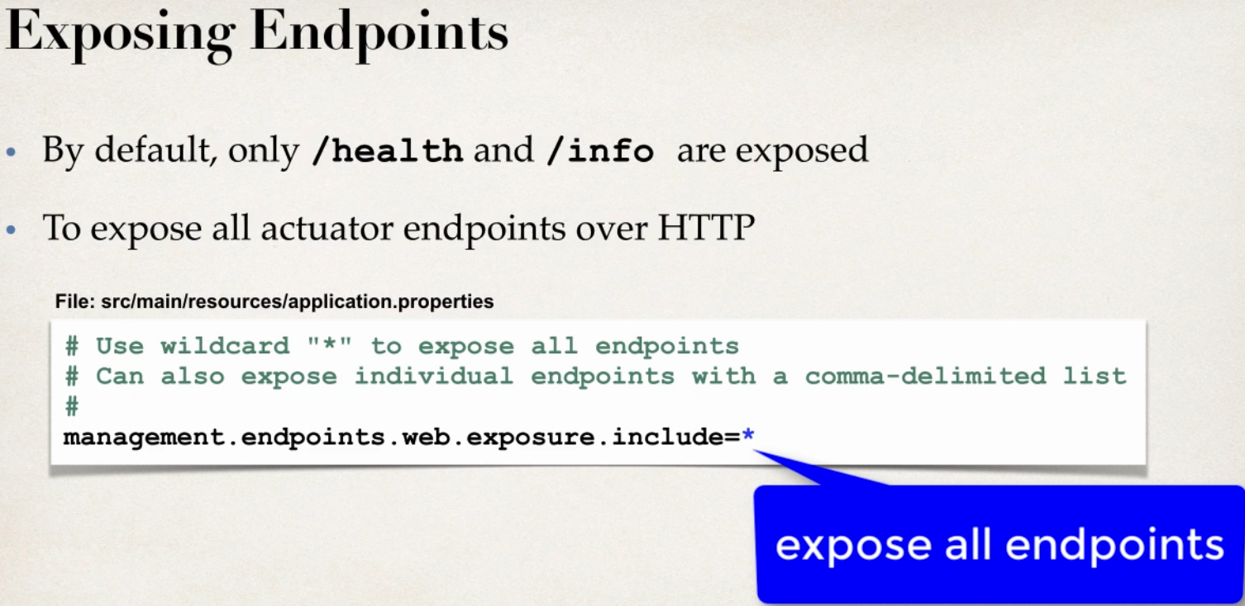

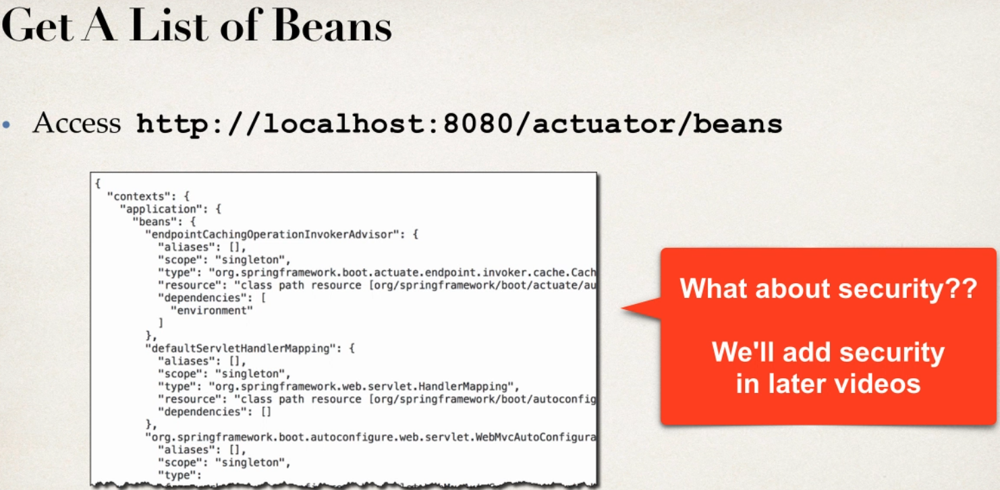

Development Process

1 add spring-boot-starter-acuator

2 view actuator endpoint for /health and /info

3 edit application.properties to customize info

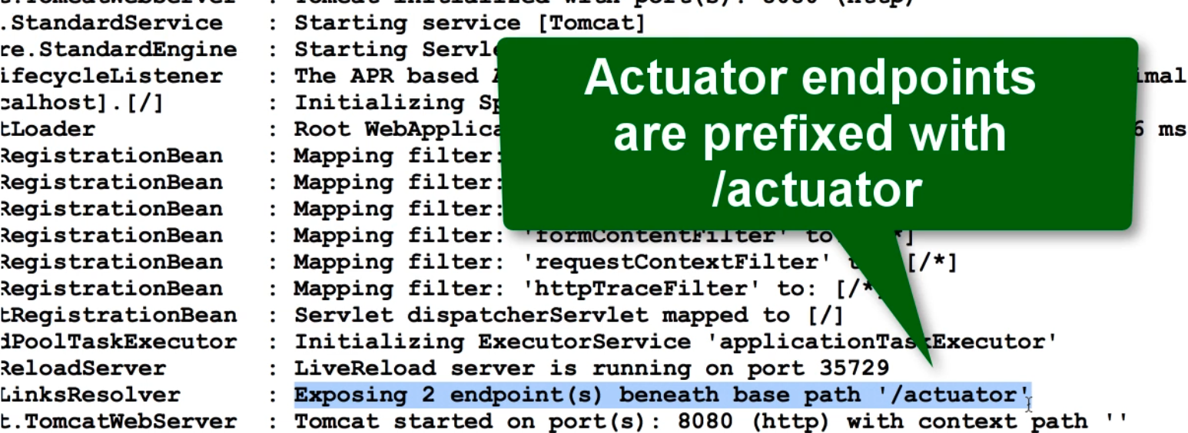

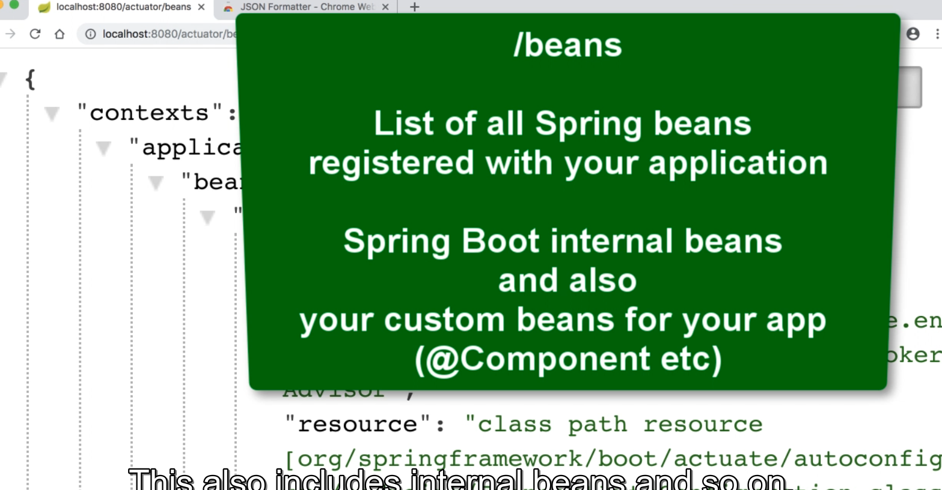

It will be used in debugging to check if bean is created or not

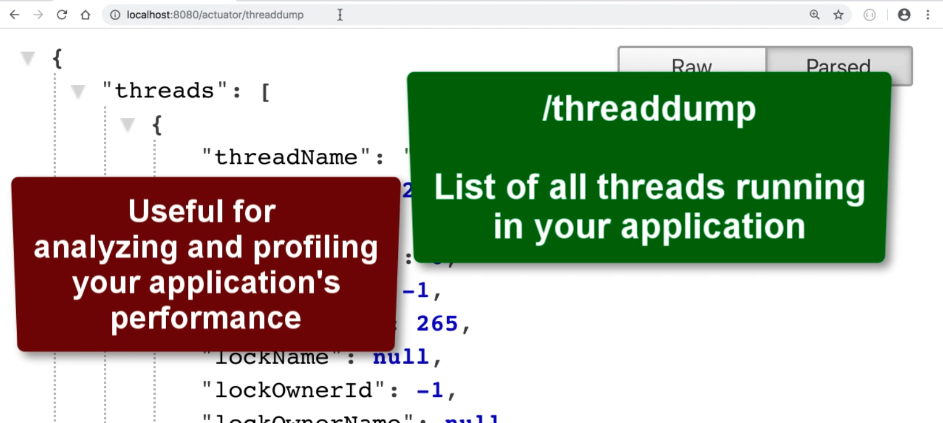

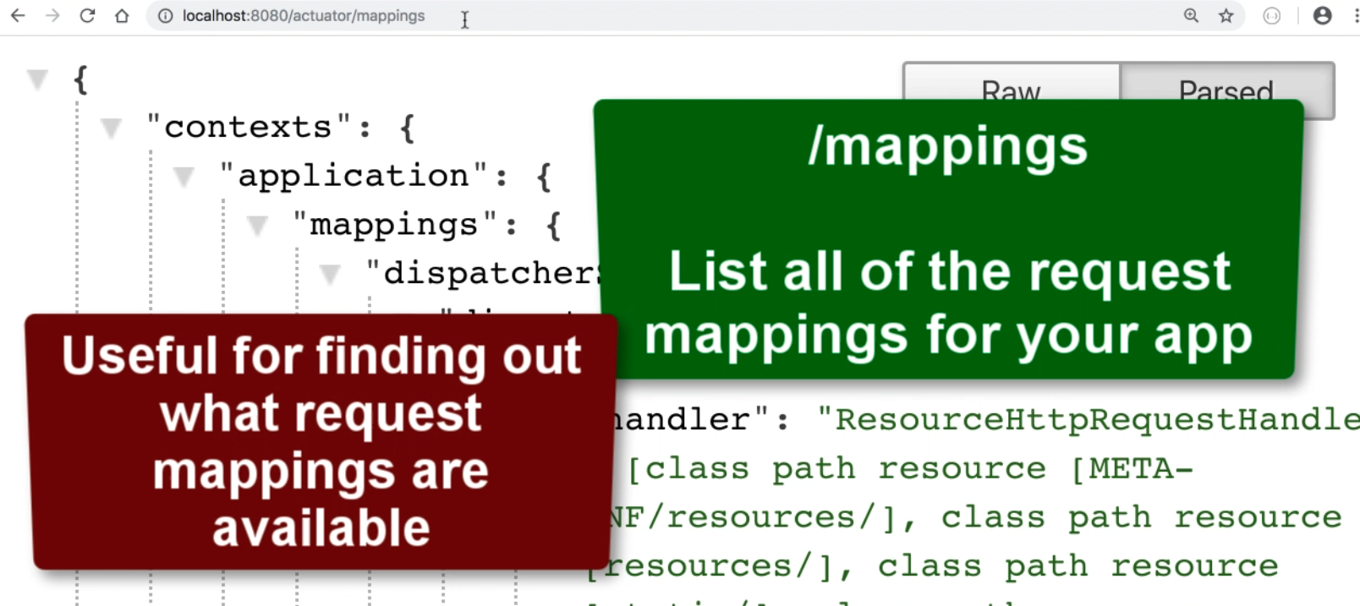

Spring Boot Actuator -Security

Q1 exposing all things will be risk what about security

-may not want expose all information

- add Spring security to project and endpoints are secured

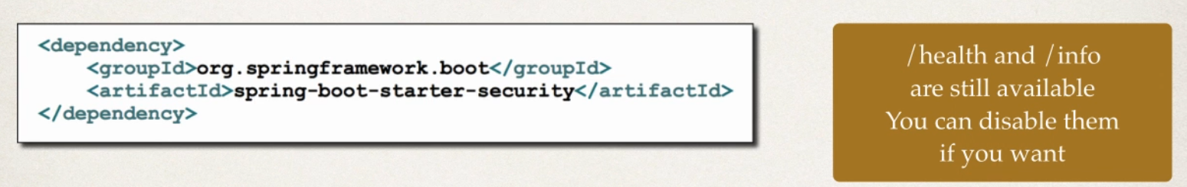

Secured Endpoints

-now when you access : /actuator/beans

-Spring Security will prompt for login

- need to login in order to access those given endpoints

-default user name will be : user

-check console logs for password

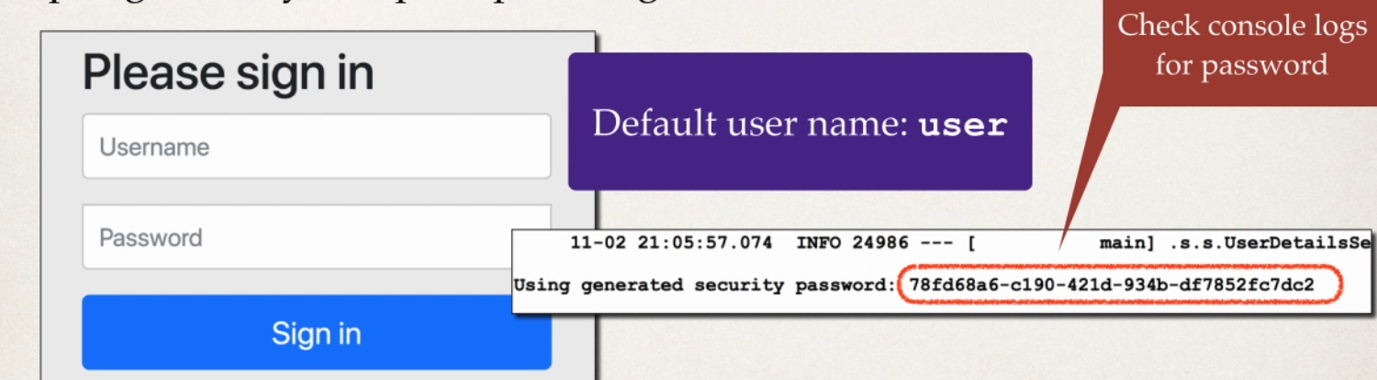

Spring Security Configuration

-you can override username and generated password

- this will be used as username and password for accessing actuator endpoints

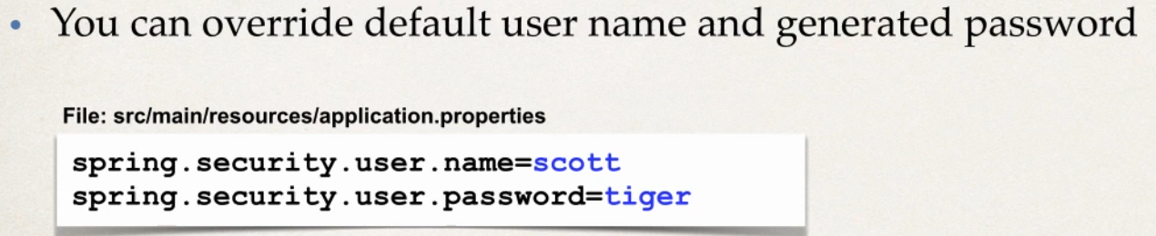

Need to do more then spring security more then just property file

Customizing Spring Security

- you can customize spring security for spring Boot Actuator

-use a DB for roles,encrypted password etc

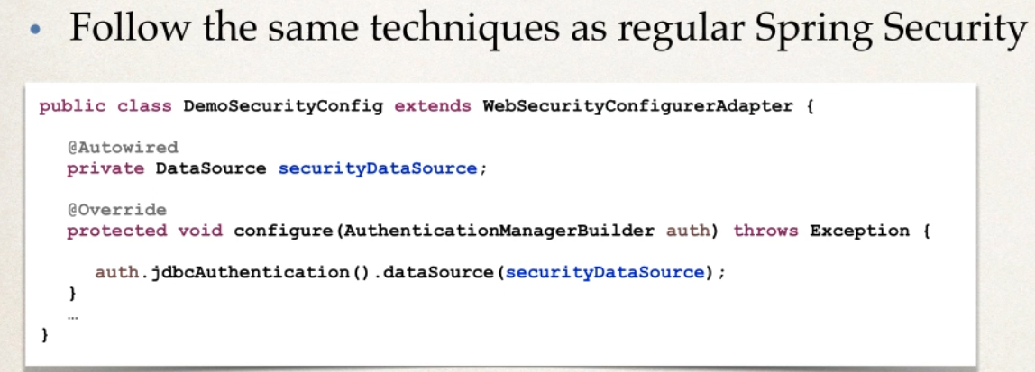

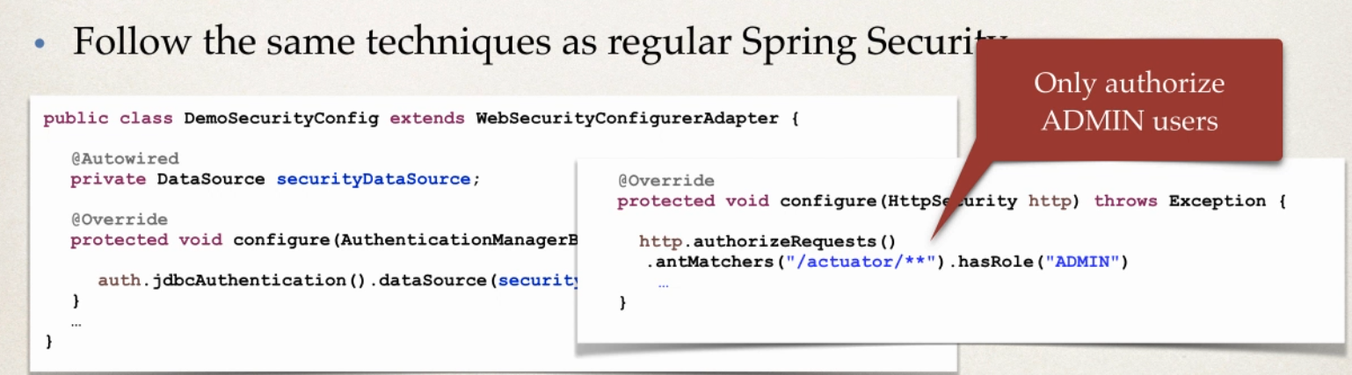

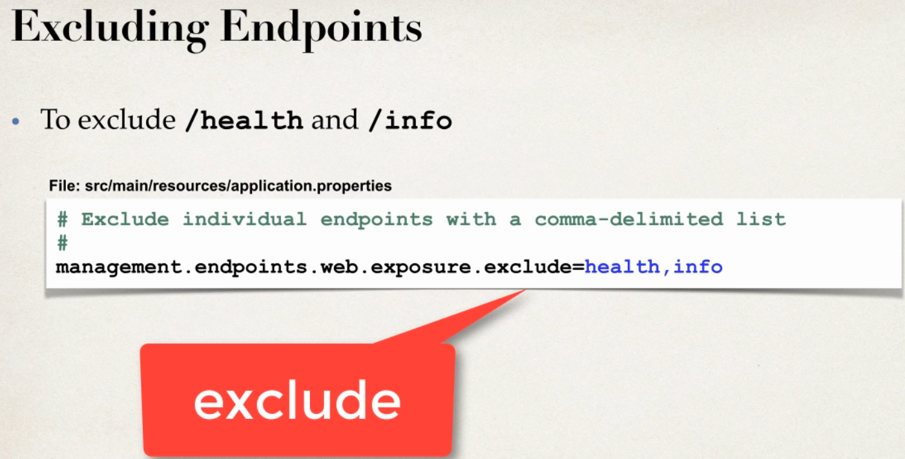

Develeopment Process

1 add pom.xml spring-boot-starter-security

2 verify security on actuator end points for /beans etc

3 disable endpoints /health and /info

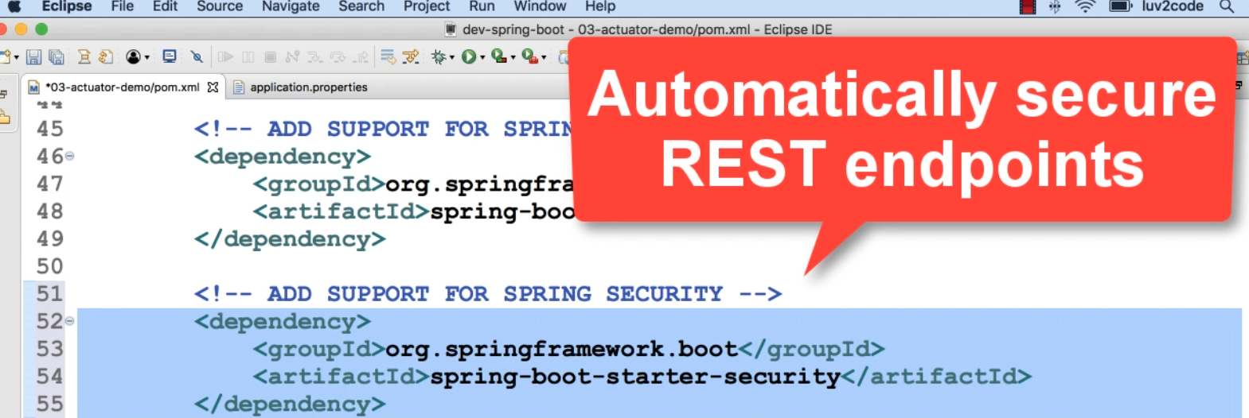

Default user name : user

Password

Using generated security password: 1464993e-9c59-4c17-accf-809a24ce2cb6

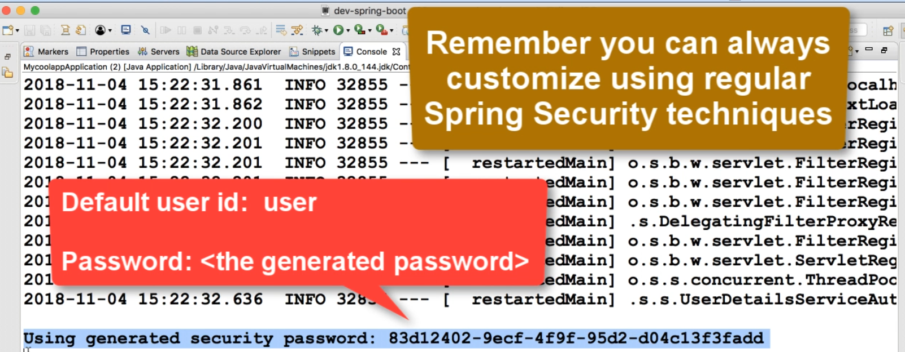

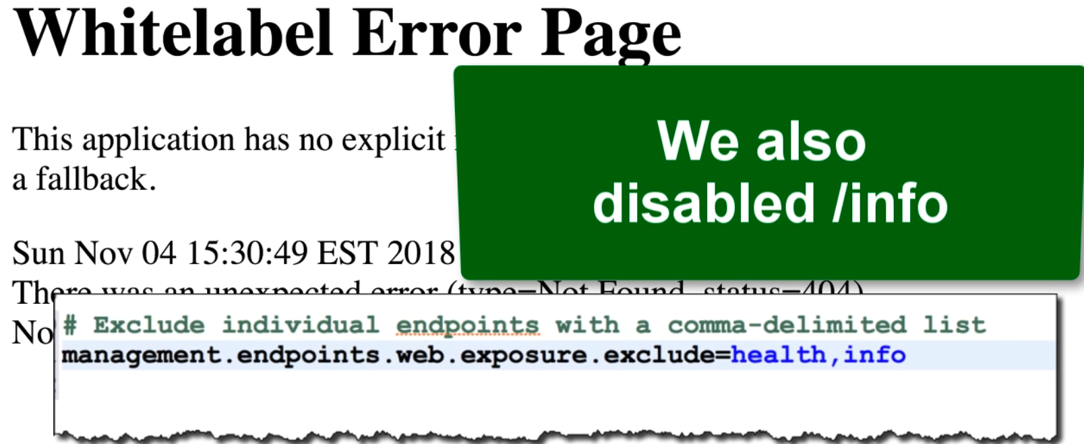

Spring Boot From Command Line

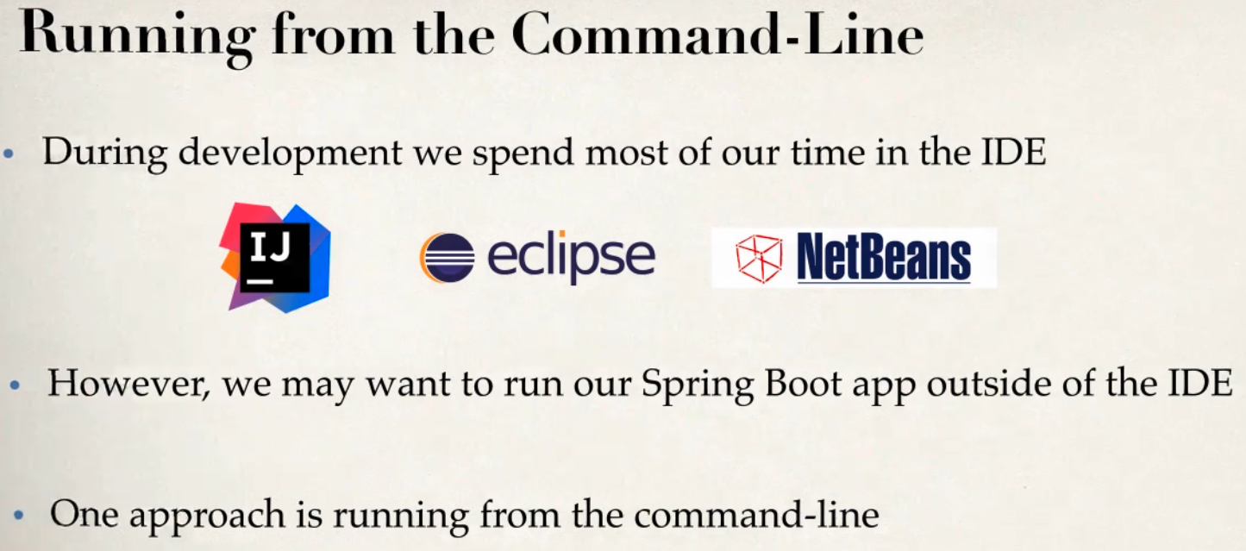

- no need to use IDE if we are using command line

-since using spring boot ,the server is embedded in jar file

-no need to install separate server and running

-spring boot apps are self contained

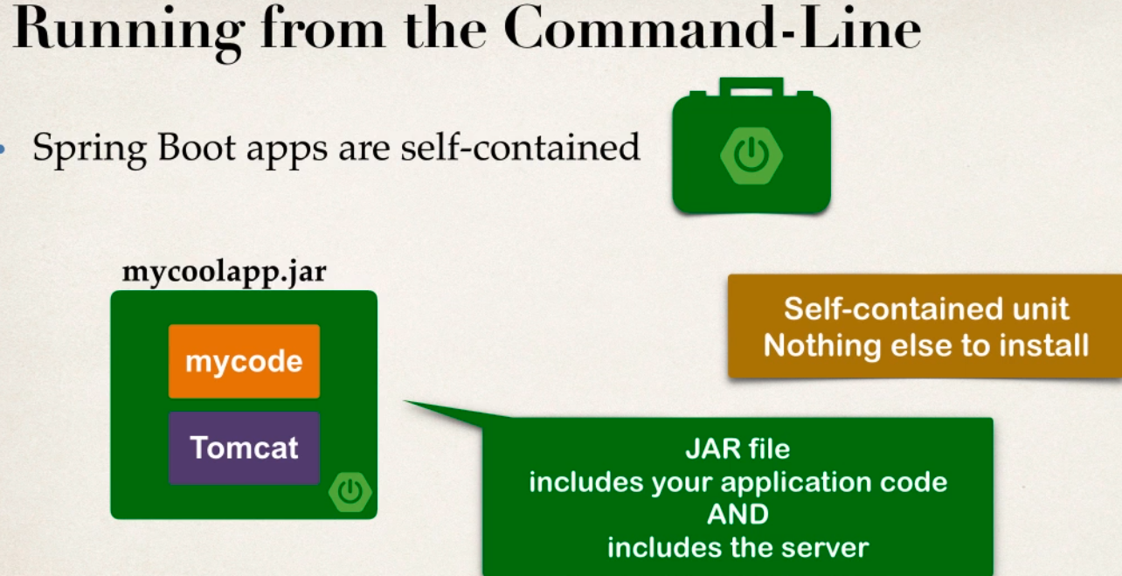

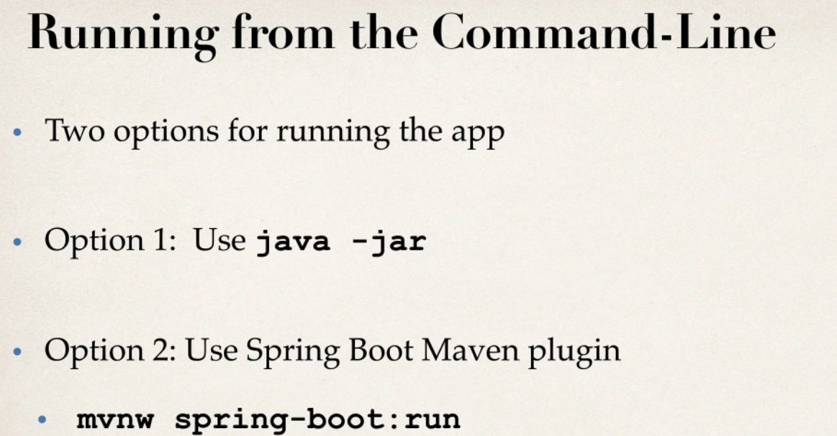

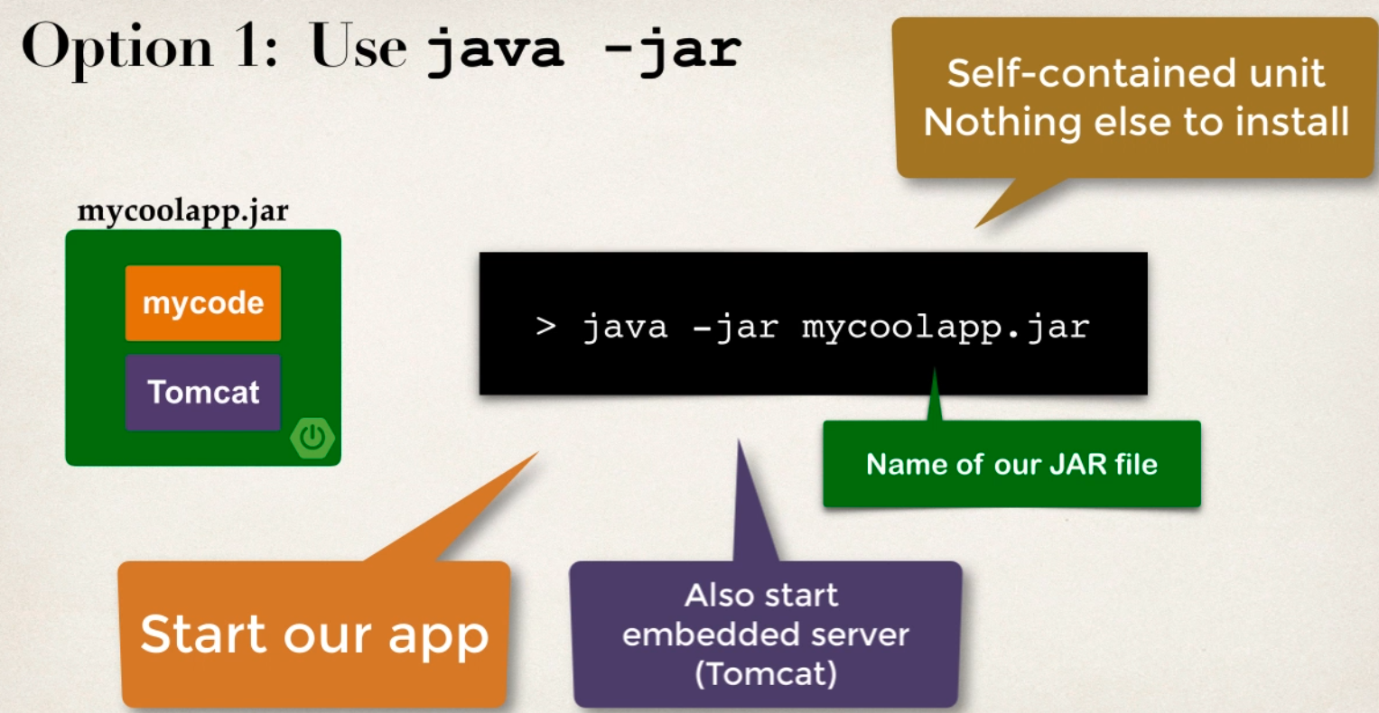

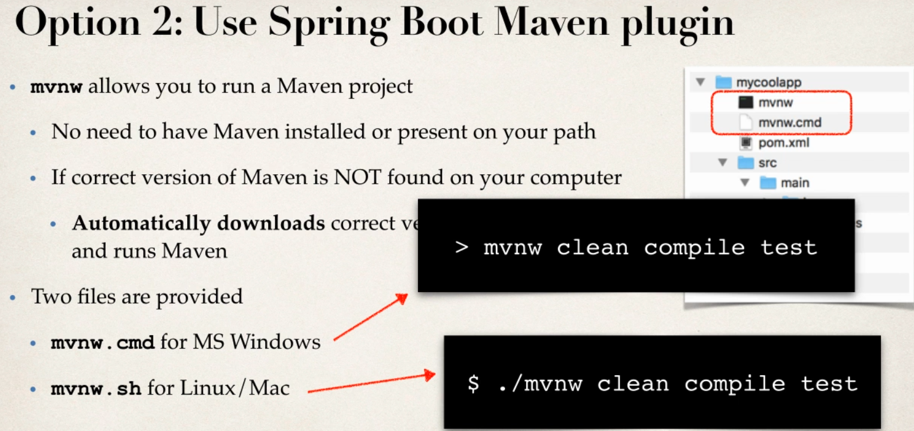

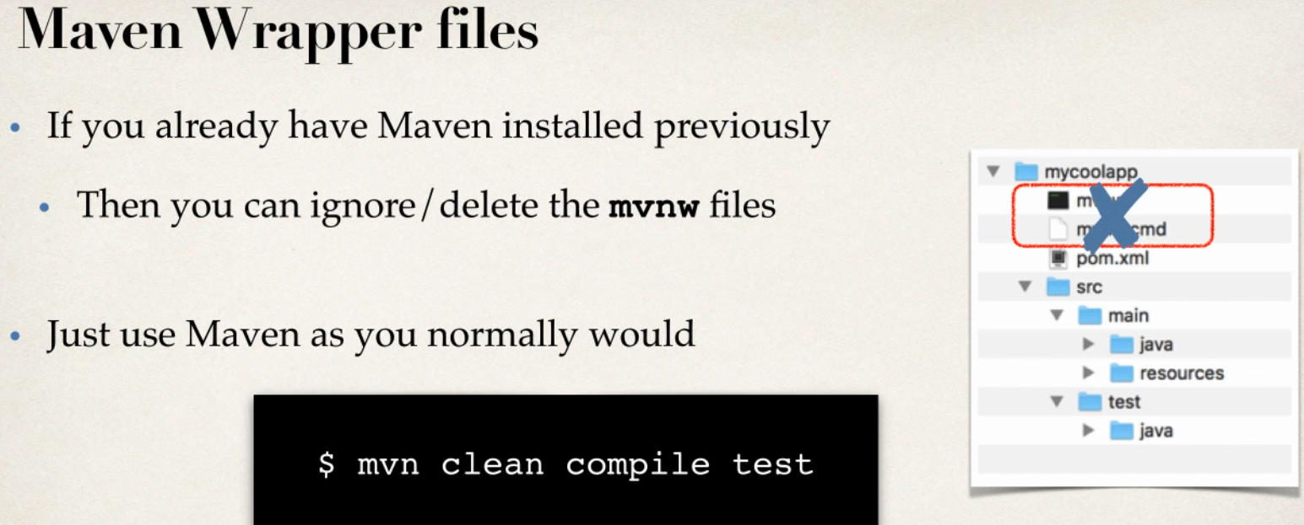

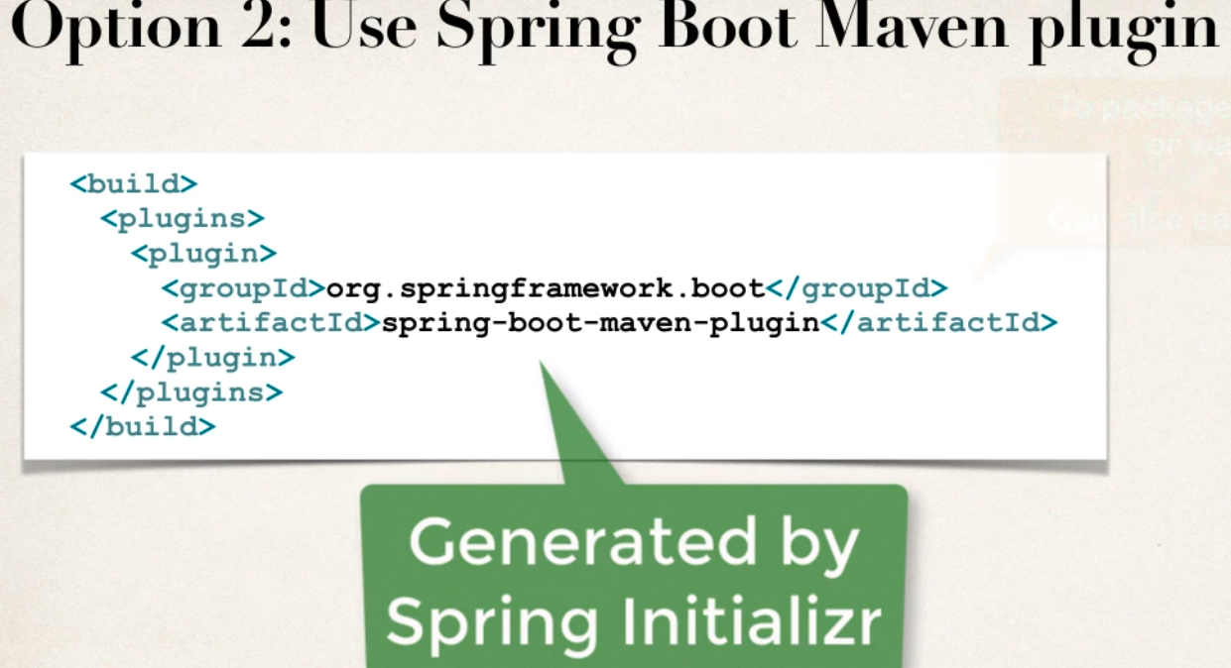

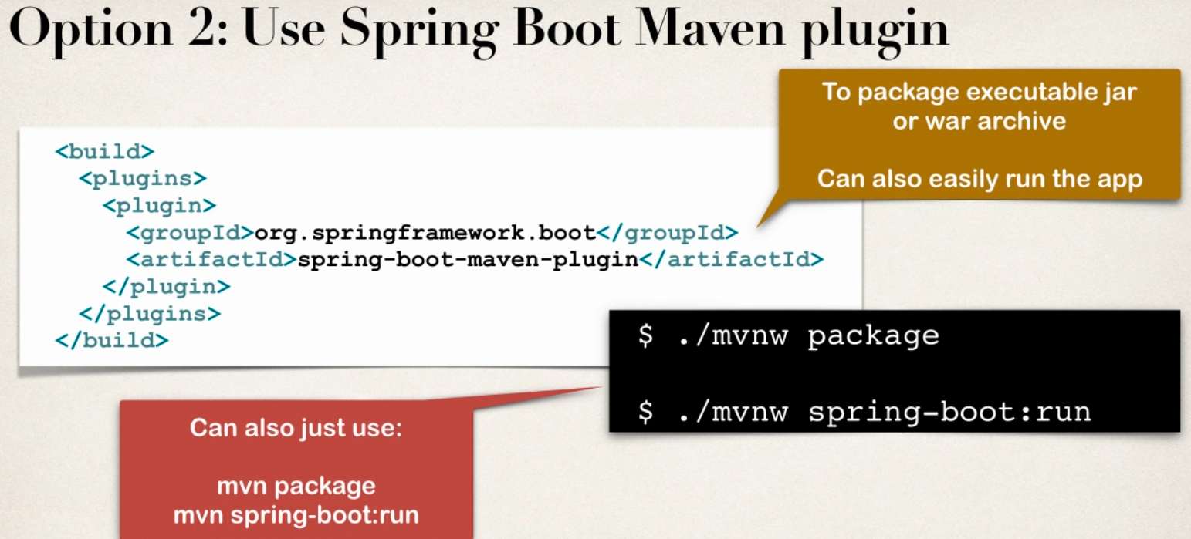

Development Process

1 Exit IDE

2 package the app using : mvnw package

3 run the app using : java -jar applicationname.jar

4 Run app using Spring Boot Maven plugin , : mvnw spring-boot:run

-move to directory of project first

-package the project using package command

If windows mvnw pacakage

In linux ./mvnw pacakge

-jar is created in the sud-directory

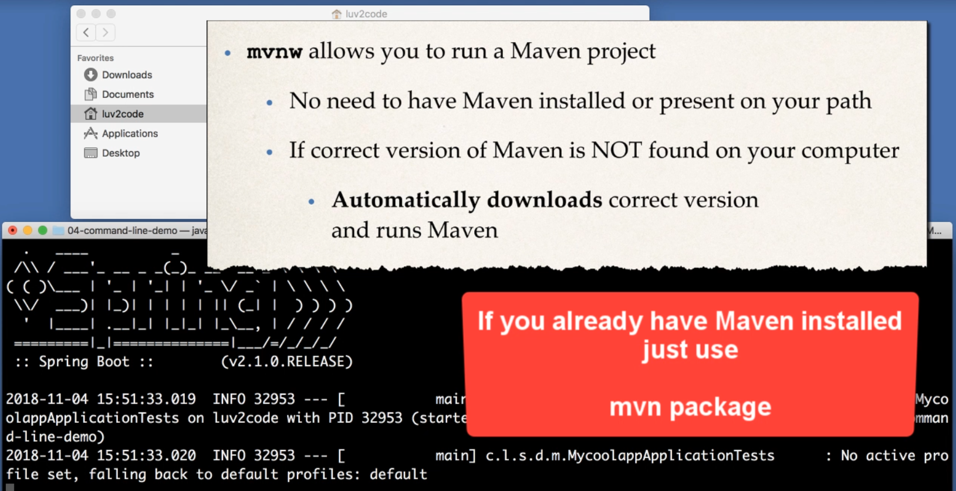

1 Go to cmd move to project directory

2 go to drive D and project path check if JAVA_HOME is set or not

3 then run mvnw package to create jar of project

4 mvnw is maven not installed if maven is installed use mvn

5 mvnw will install curretn version of maven

6 target foledr will get jar file

7 java -jar project.jar

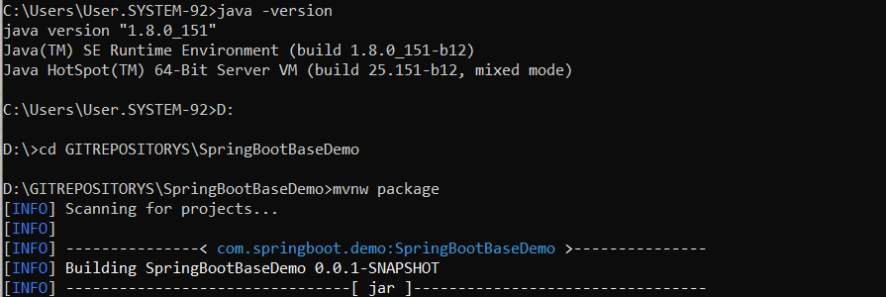

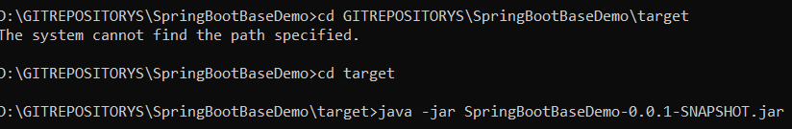

Spring boot run using Maven plug in

Spring Boot -Custom Application Properties

Problem

- our app need to be configurable - no hard coding of values

-need read app config from properties files

Solution

Application.properties file

- by default, spring boot reads information from a standard properties files

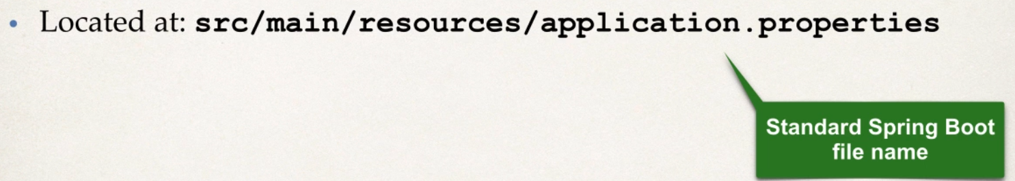

- you can define any CUSTOM properties in this file

-your spring boot app can access properties using @value

- no additional coding or configuration required

Development Process

1 define custom properties in application : application.properties

2 inject properties into spring boot application using @value

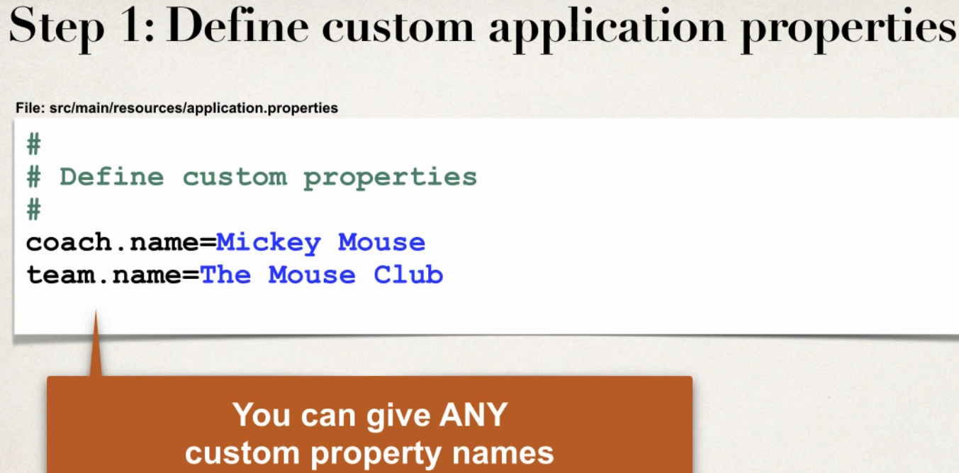

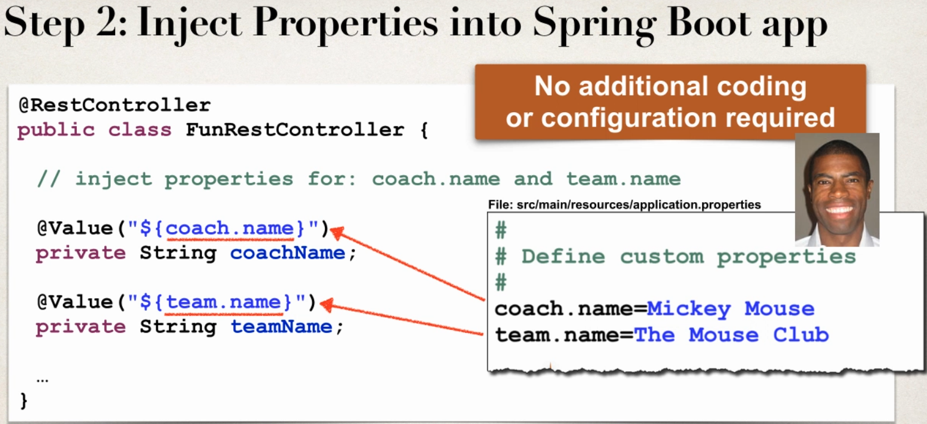

Spring Boot Properties

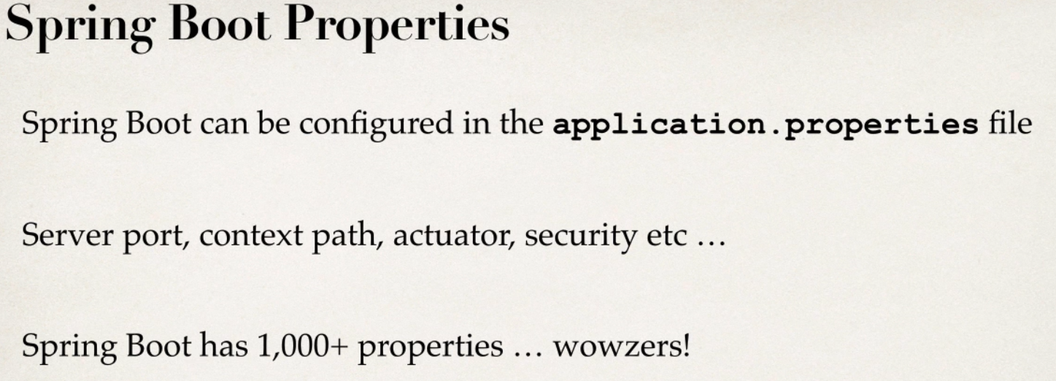

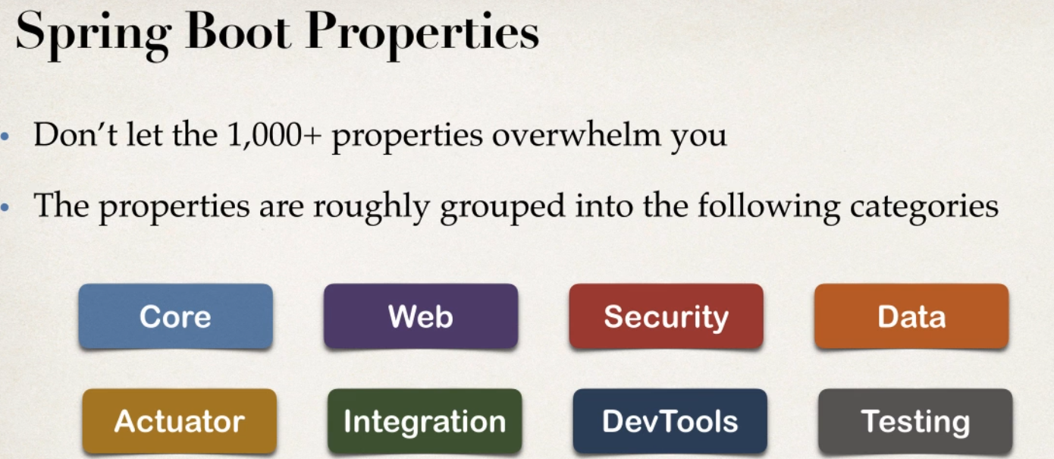

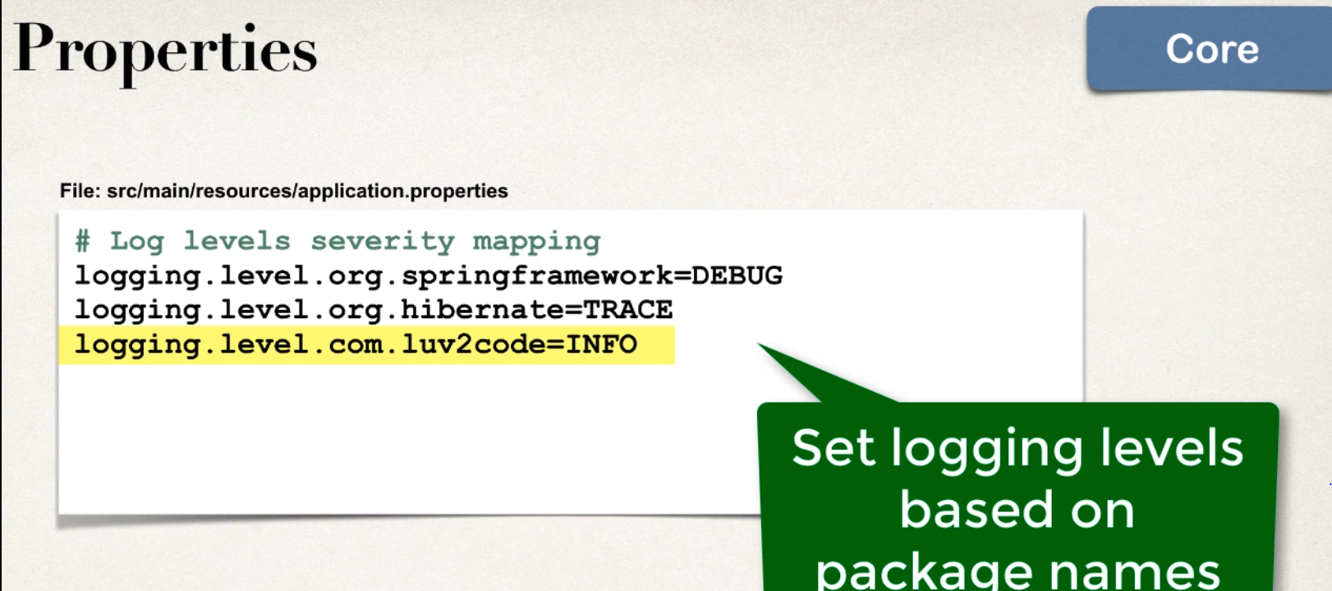

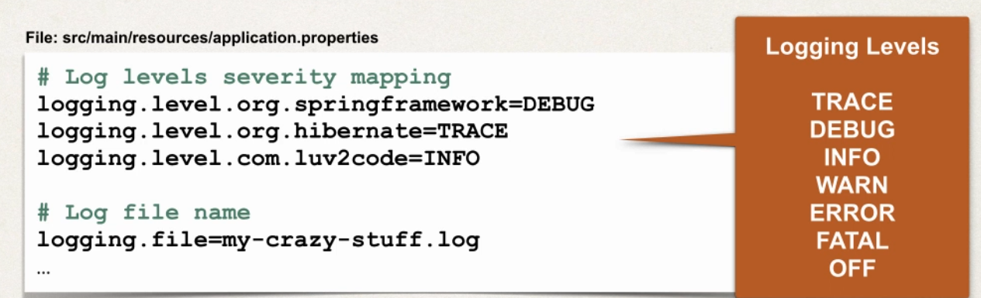

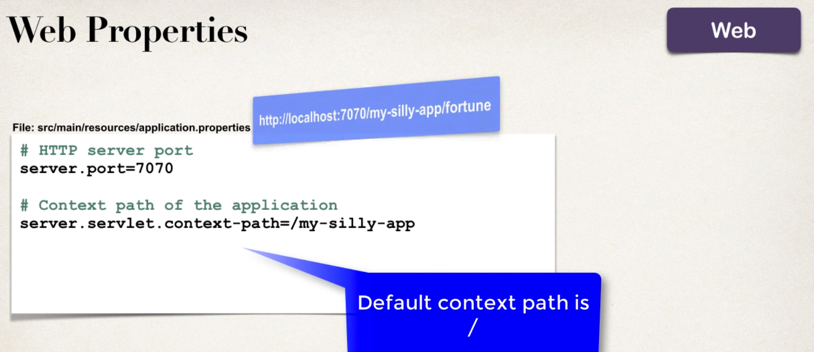

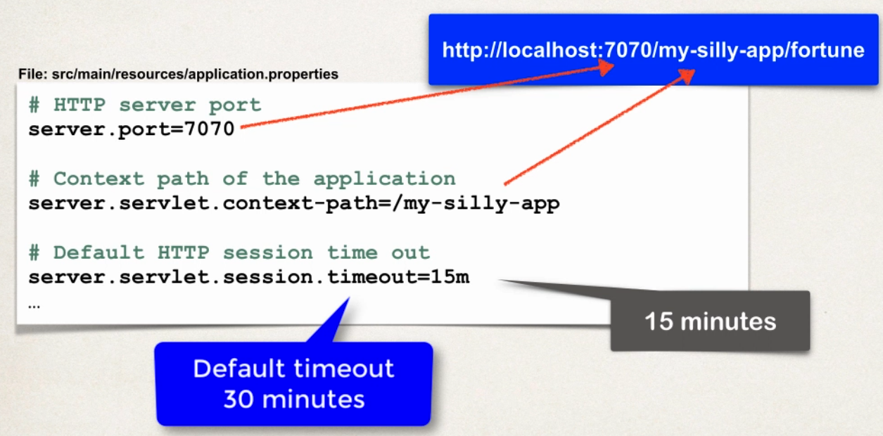

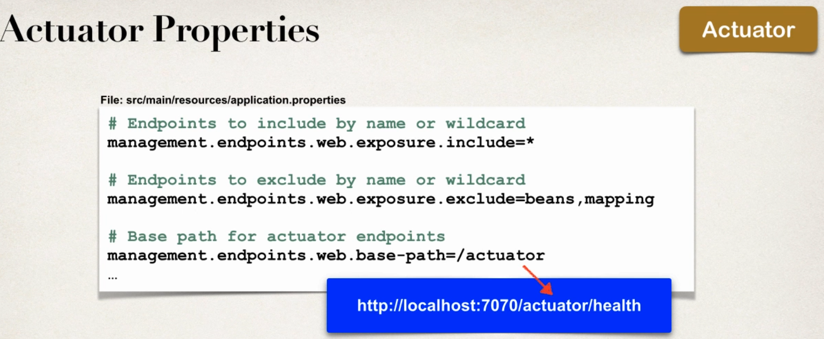

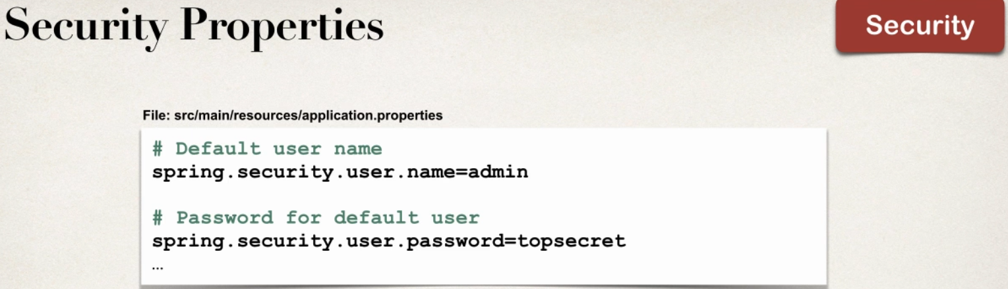

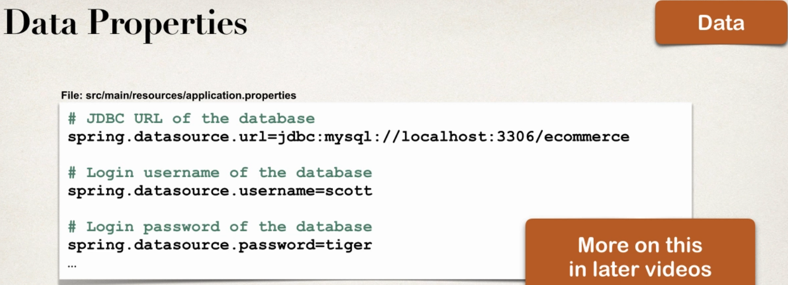

Development Process

1 configure server port

2 configure application context Path

Spring Boot Rest API Real Time Project

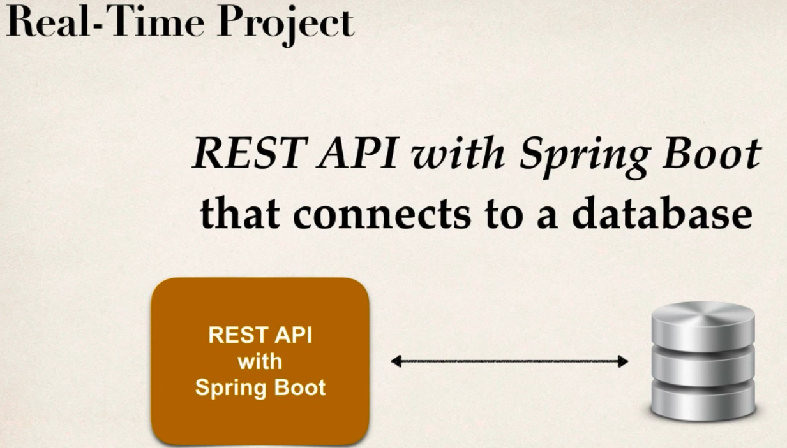

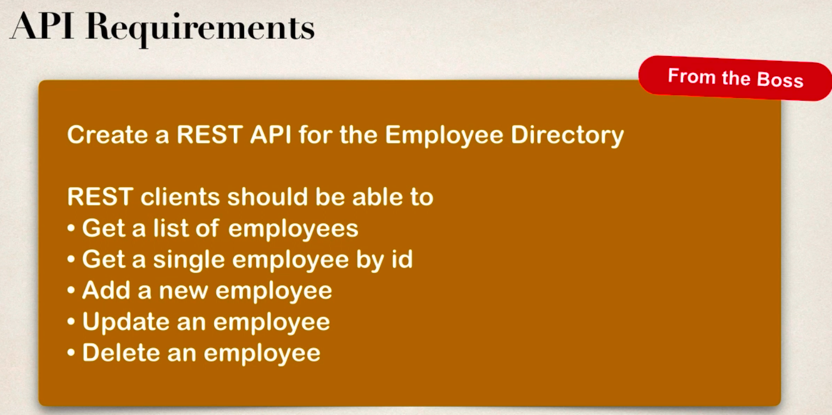

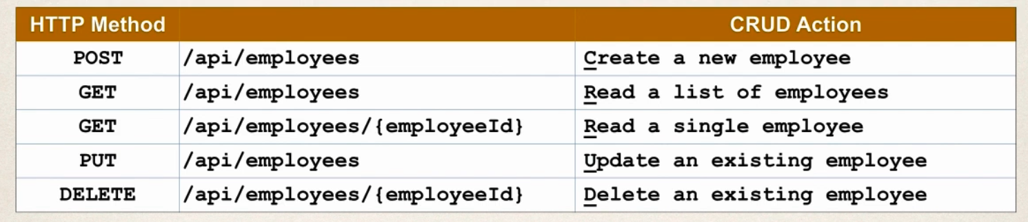

Development Process

1 set up Database Dev Environment

2 create Spring Boot using Spring Inttializar

3 Get list of emolyees

4 GEt Single EMployee By Id

5 Add new Employee

6 updating an existing employee

7 delete an existing employee

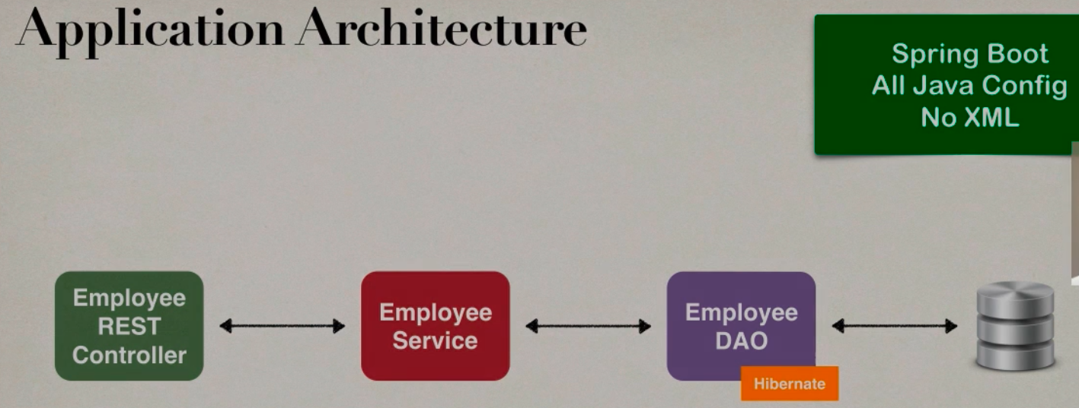

Step 1:

Setup table

Employee table

create table employee (id NUMERIC(10) PRIMARY KEY not null,

first_name VARCHAR(100) DEFAULT NULL,

last_name VARCHAR(100) DEFAULT NULL,

age NUMERIC(3) DEFAULT NULL,

email varchar(100) DEFAULT NULL

)

Insert Data to table

insert into employee VALUES

(nextval('employee_id_seq'),'sachin','gowda',27,'sachin@gmail.com'),

(nextval('employee_id_seq'),'darshan','gowda',35,'darshan@gmail.com'),

(nextval('employee_id_seq'),'manasa','gowda',28,'manasa@gmail.com')

Step 2 :

Create Spring Boot Project using Spring Initializer

1 web,devtools,jpa,postgress as dependencies

Creating DAO in SPring BOOT

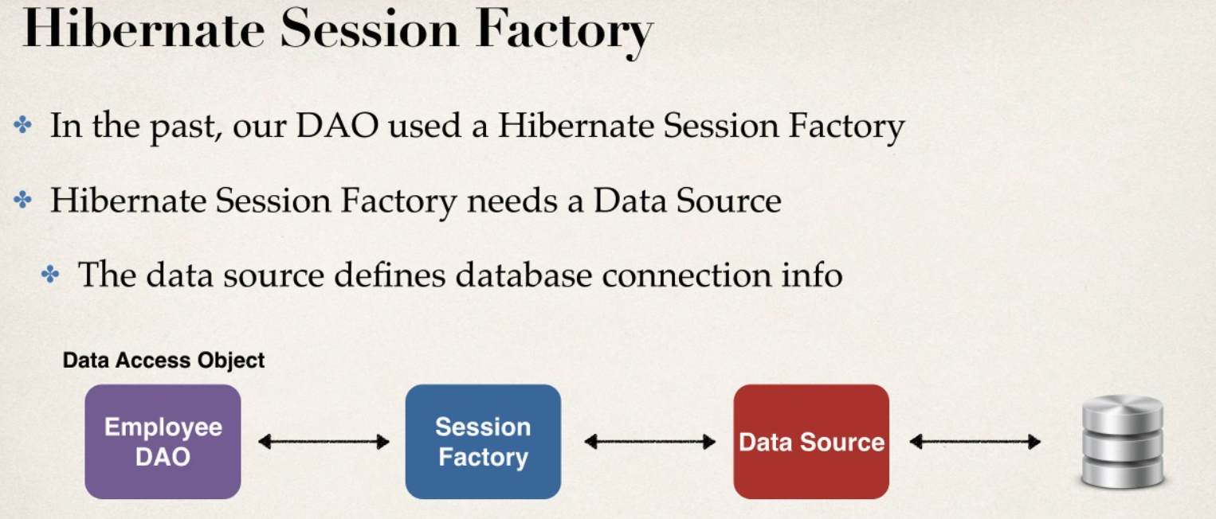

Traditional spring

-normllay had configure manually

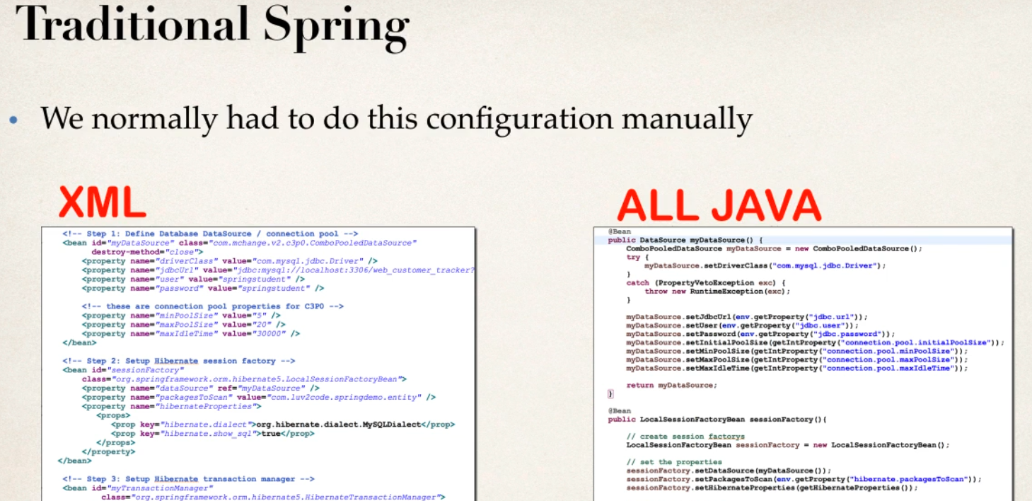

Spring Boot Rescue

- Spring Boot will automatically configure your data source

-based on entiers from pom.xml

- JDBC driver

-spring data-orm

-DB connection info from application.properties file

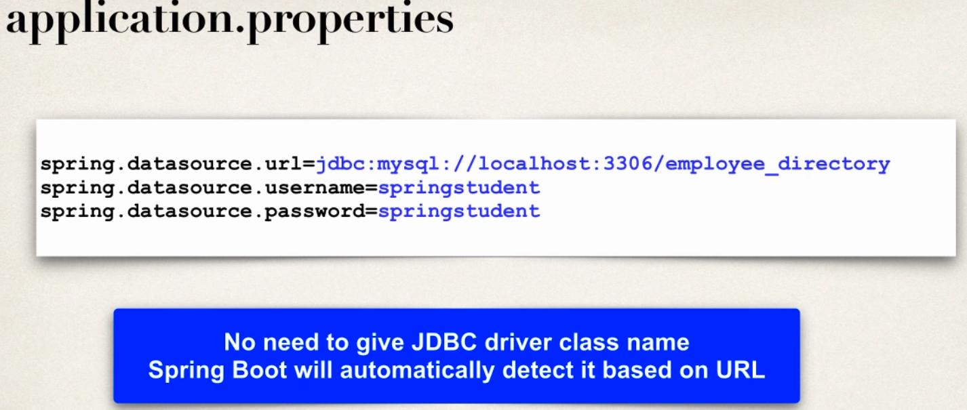

Additional Data source properties

-properties are available to configure connection pool

-- spring.datasource.*

Auto Data Source Configuration

- based on configs,spring Boot will automatically create the beans

DataSource,EntityManager

-smae can be injected in our App in DAO

- EntityManager is from Java Persistance API(JPA)

What is JPA?

- java Persistance Api (JPA)

- standard API for Object -relation- mapping(ORM)

-only specifcation

-define set of interfaces

- requires an implementaion and usable

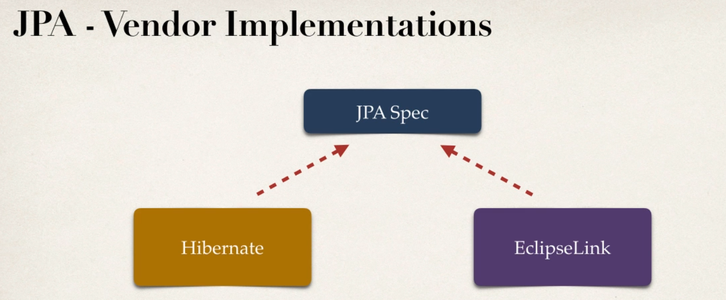

Hibernate is the most used implementaion for JPA

Benefits of JPA

-By having standard API you are not locked to vendore implementaion

-maintain portable,flexible code by codeing JPA spec(interface)

- theoretically we can switch vendor implementations

-for ex if vendor ABC stop supporting thier support then can switched vendor XYZ without vendor lock in

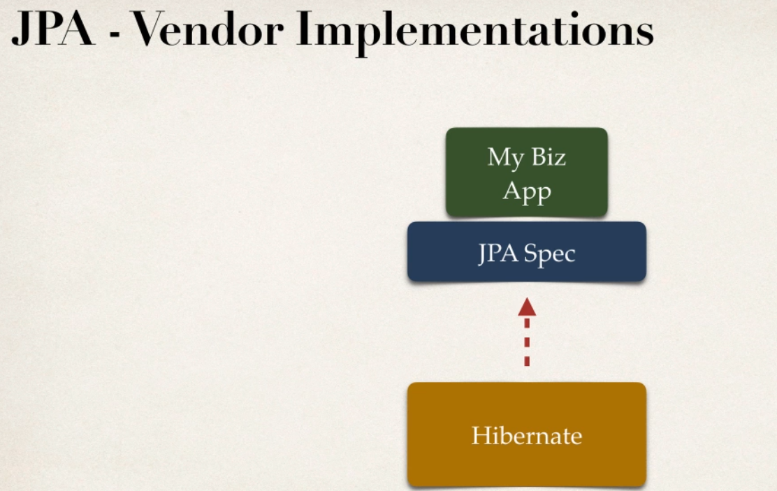

Auto Data Source Configuration

-in Spring Boot , Hibernate is default implementaion of JPA

- EntityManager is similarr to Hibernate SeesionFActory

- EntityManager can serve as wrapper for Hibernate Session object

- we can Inject EntityManager into our DAO

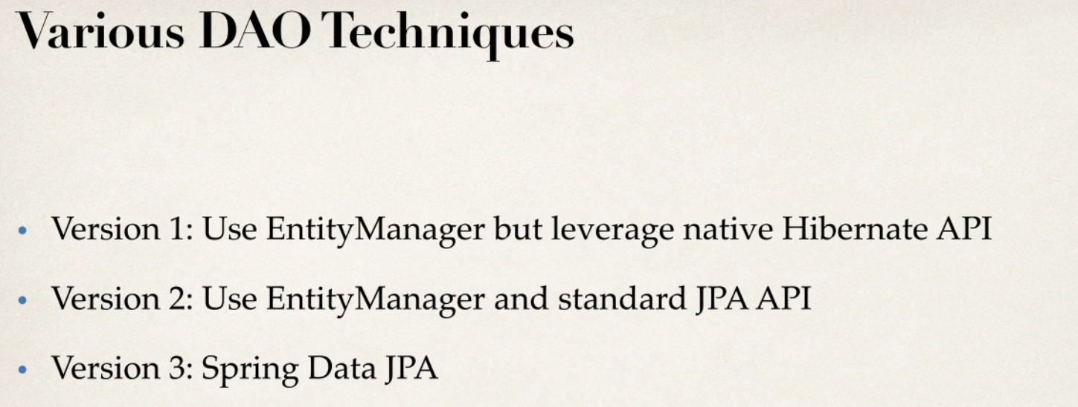

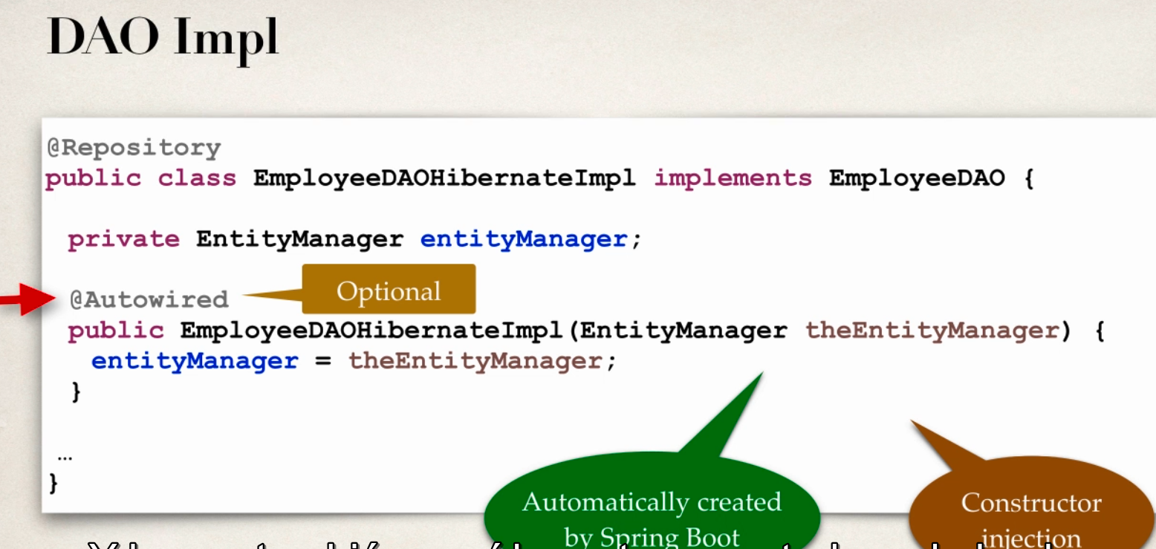 -any injection is possible just trying Constructor injection

Autowired is optional bcz in latest spring if u a class have only one constructor then no need to use Autowire if its constructor injection .

-spring will automatically do it for us

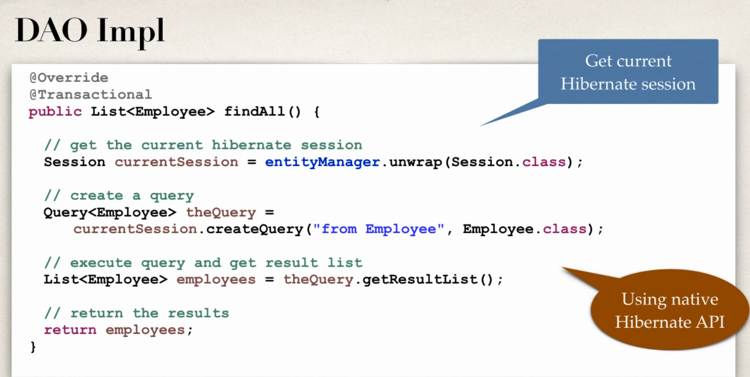

Development Process

1 update DB config in application.properties

2 create Employee entity

3 Create DAO interface

4 Create DAO implementaion

5 create REST controller to use DAO

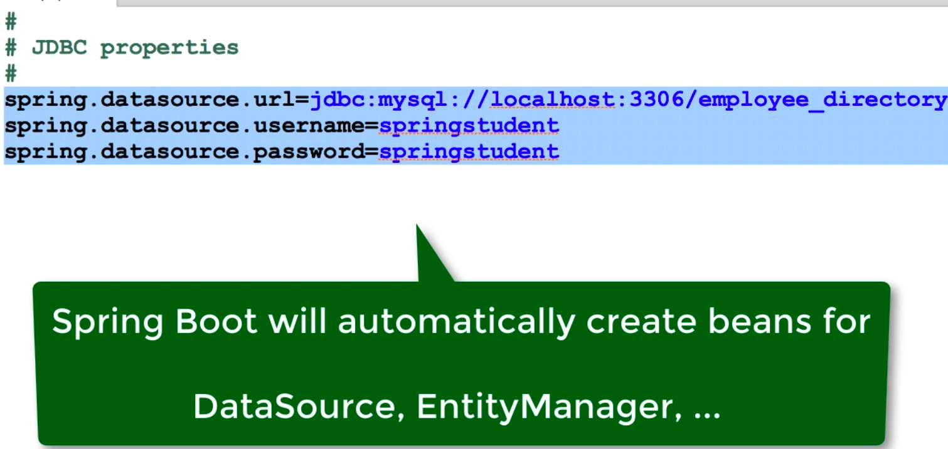add all this in application.properties files

No need to define datasourc.driver bcz url only auto identify the driver

REST methods to FIND and Add Employee

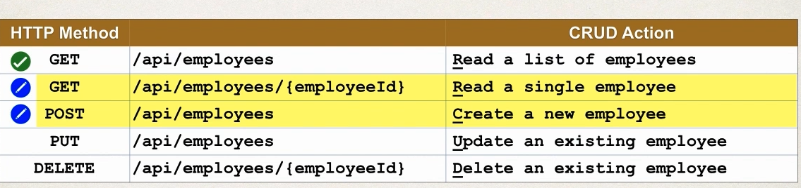

REST METHOD to Update and Delete EMployee

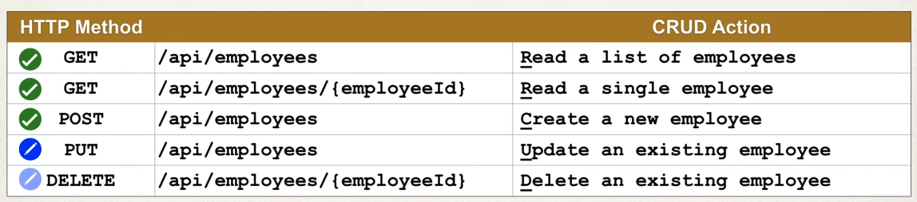

Create JPA DAO in SPring BOOT

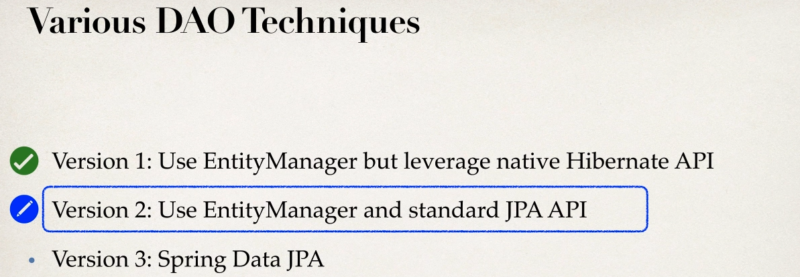

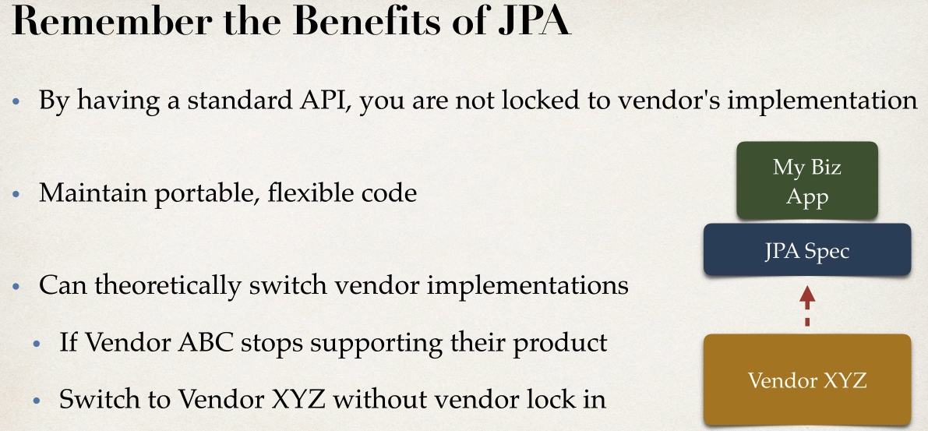

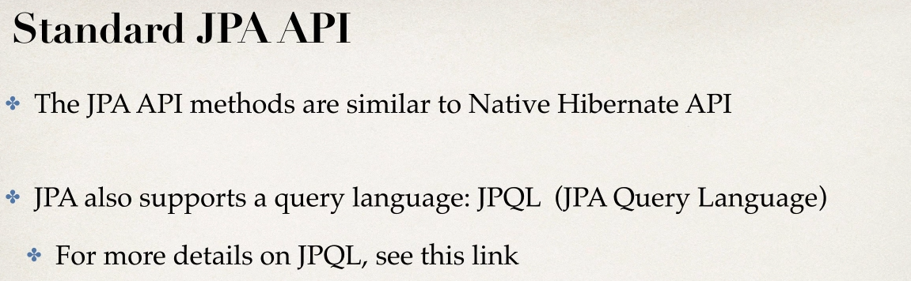

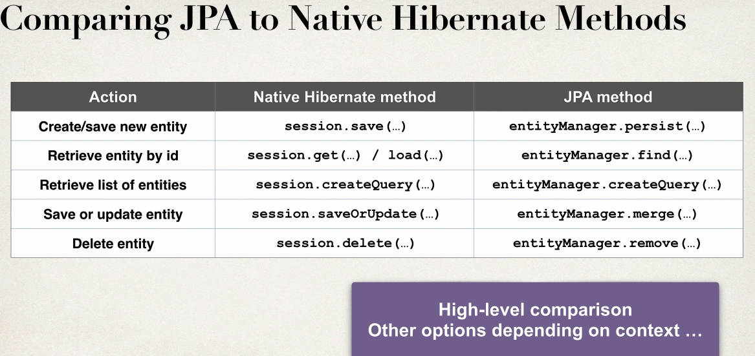

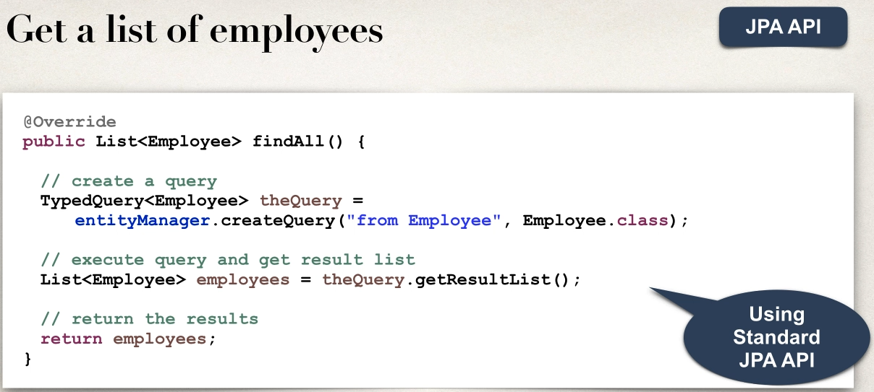

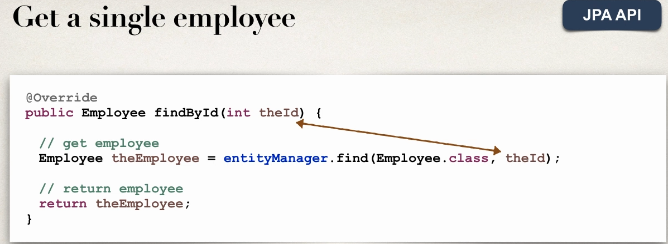

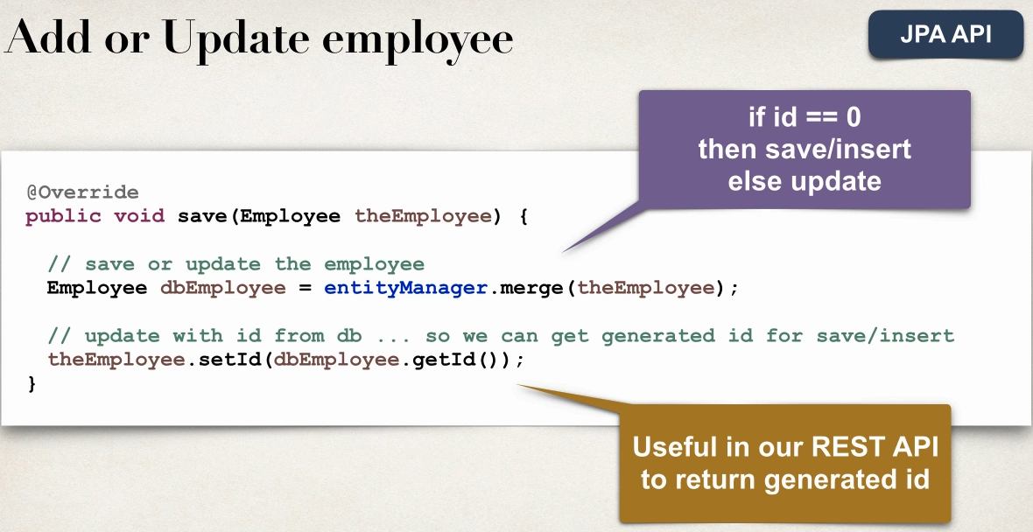

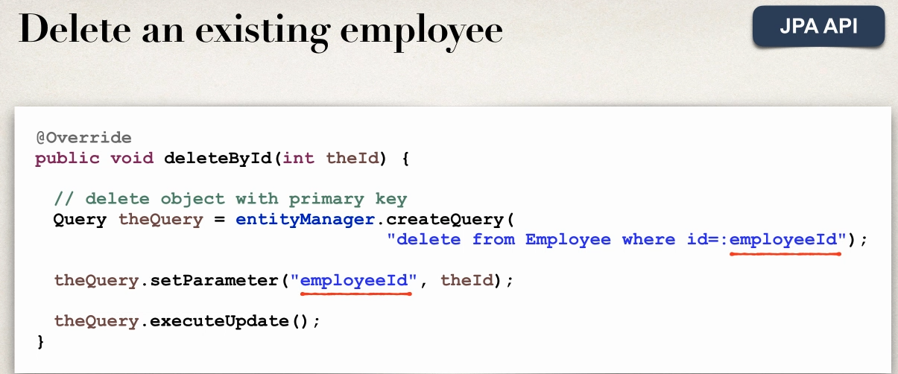

Spring Data JPA in Spring Boot

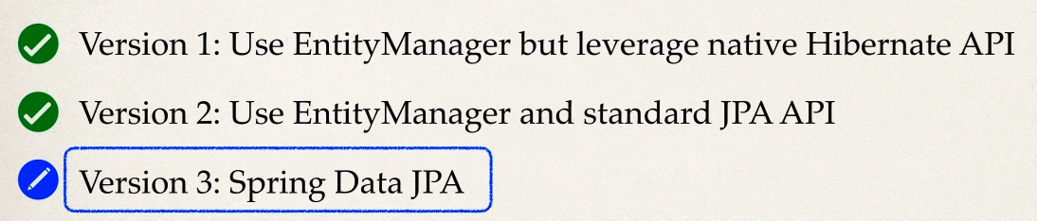

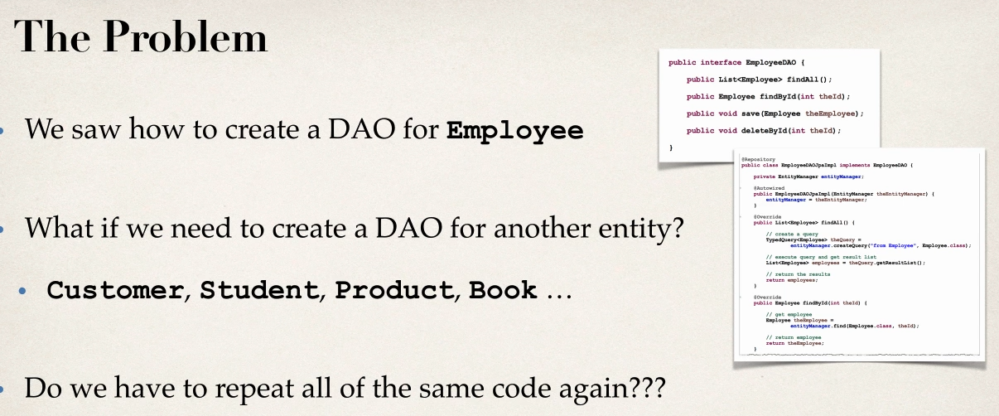

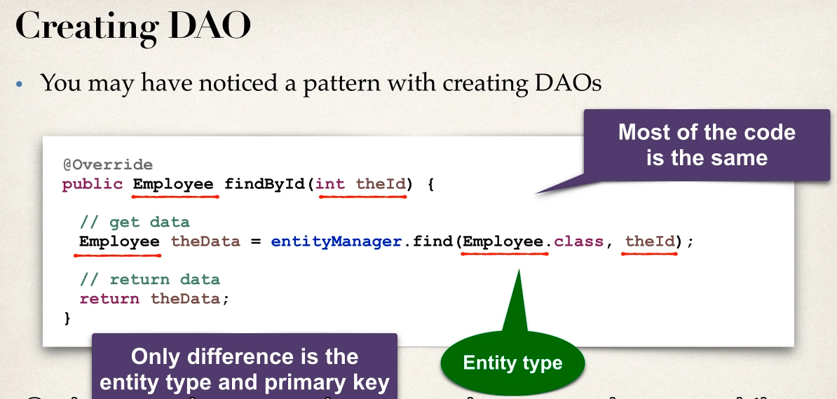

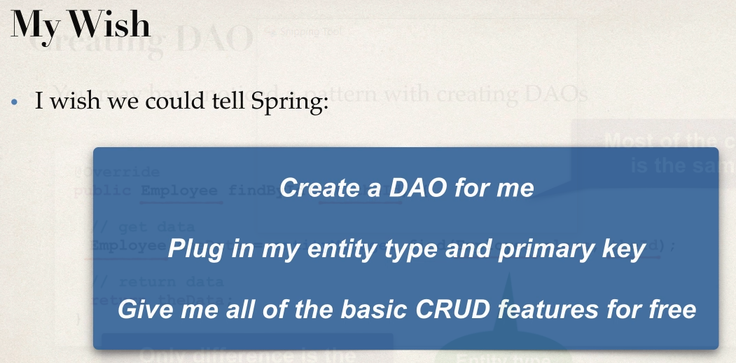

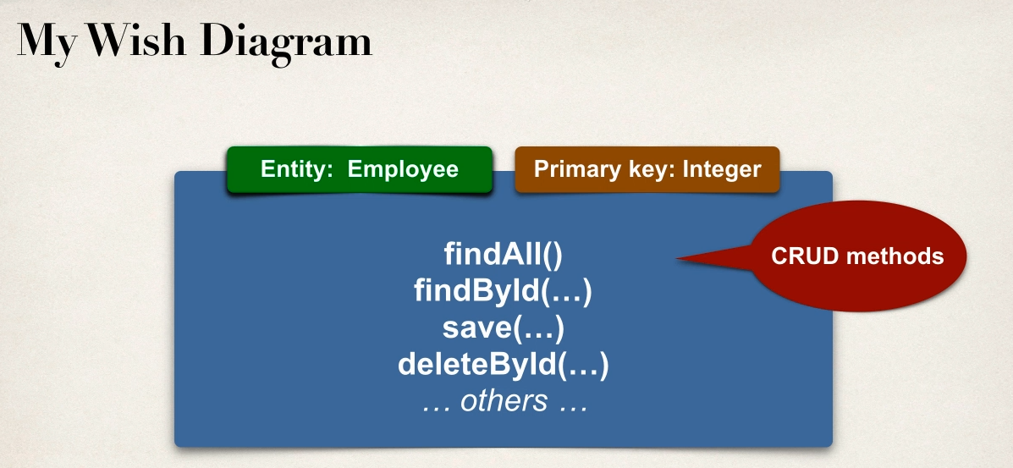

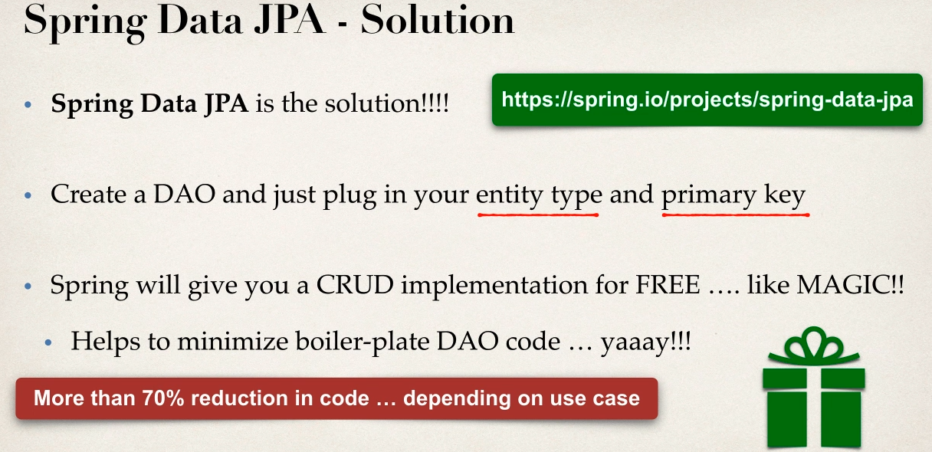  
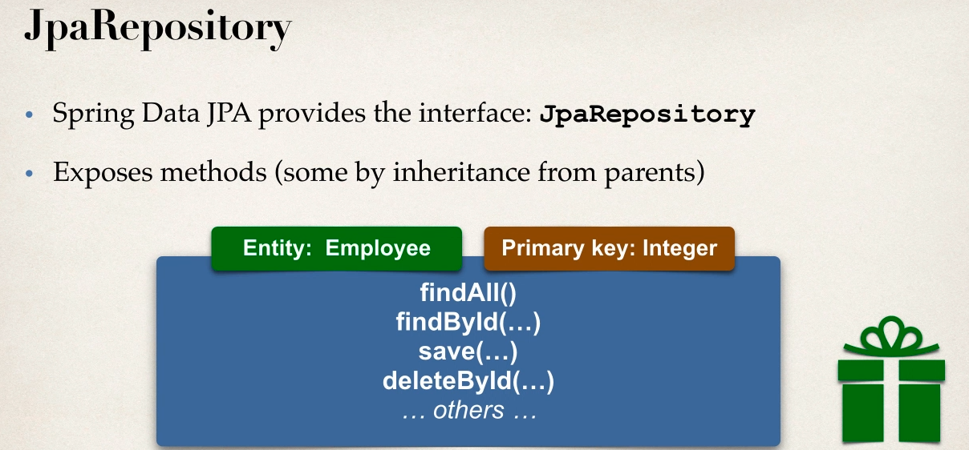

Development Process

1 Extend JpaRepository

2 use Repository in App

3 no need for implementaion class

